Preface
This document is prepared by the College of Engineering and Technology to assist the students in the preparation of their final year project report. The document is intended to be used in its electronic form directly, as a template, and is format standardized so that all the students’ reports should appear in this format.
The document contains guidance for all the chapters, headings and sub-headings necessary to include into the report; such as abstract, introduction, table of contents, list of figures, list of tables, and the other main chapters of the report ending with the results, discussion, and future work chapters. Furthermore, the report explains clearly the proper method for citing previous work and including a list of references in a standard format.
The format and the guidance for preparing the final year project report are designed to satisfy the requirements for accreditation and validation of the undergraduate engineering programs by the Accreditation Board of Engineering and Technology (ABET) in the US and the Engineering Accreditation Board (EAB) in the UK.
All students must abide with all that comes in this document upon preparing their final year project report.

Arab Academy for Science, Technology and Maritime Transport

College of Engineering and Technology
<Department Name>
B. Sc. Final Year Project
<PROJECT TITLE>
Presented By:
<Student Name> | <Student Name>
<Student Name> | <Student Name>

Supervised By:
<Supervisor(s)>

MONTH – YEAR

DEclaration
I hereby certify that this report, which I now submit for assessment on the programme of study leading to the award of Bachelor of Science in <insert title of degree for which registered>, is all my own work and contains no Plagiarism. By submitting this report, I agree to the following terms:
Any text, diagrams or other material copied from other sources (including, but not limited to, books, journals, and the internet) have been clearly acknowledged and cited followed by the reference number used; either in the text or in a footnote/endnote. The details of the used references that are listed at the end of the report are confirming to the referencing style dictated by the final year project template and are, to my knowledge, accurate and complete.
I have read the sections on referencing and plagiarism in the final year project template. I understand that plagiarism can lead to a reduced or fail grade, in serious cases, for the Graduation Project course.

Student Name:  Registration Number:  Signed: ________________________  Date: DD – MMM – YYYY | Student Name:  Registration Number:  Signed: ________________________  Date: DD – MMM – YYYY
Student Name:  Registration Number:  Signed: ________________________  Date: DD – MMM – YYYY | Student Name:  Registration Number:  Signed: ________________________  Date: DD – MMM – YYYY
STUDENTS CONTRIBUTION

Although your project will have a single title with all student names meaning that it is a group project; however, each student must have at least one individual part, including his own aims and objectives, tests, analysis and results verification. Each student should also exactly define his own work in the other shared parts. This individual work will be considered in final evaluation and presentation of each student.

Guiding Example
<PROJECT TITLE>

By:

<Student (A)>
<Student (B)>
<Student (C)>
<Student (D)>

Chapter | Title | Contributors
1 | Introduction | Student (A)  Student (B)
2 | Survey | Student (C)  Student (D)
3 | Simulation analysis part 1 | Student (A)
4 | Simulation analysis part 2 | Student (B)
5 | Practical verification part 1 | Student (C)
6 | Practical verification part 2 | Student (D)
7 | Conclusions and discussions | Student (A)  Student (B)  Student (C)  Student (D)

DEDICATION
Should you choose to include a dedication, it should be centered vertically on the page. If you choose, you may center it horizontally as well, provided that it is no longer than a paragraph. There should be no heading on the dedication page.

Acknowledgment
Use this section to acknowledge the contribution of different people to your work; these may include your supervisor(s), industry partners, sponsors, financial support, specific faculty members in your department, and even your family.

Abstract
The report must begin with a one- to two-paragraph abstract (200 – 250 words) that orients the reader as to the contents as well as to the major sections of the report. The abstract, by itself, must provide enough information about the project so that the reader can judge simply by reading this portion if he or she wants to read further.
For example, as an abstract for this document, this document has been prepared by the College of Engineering and Technology to help undergraduate students in preparing their final year project report. This document aims at presenting the general outline for final year project reports as well as the formatting that students must abide to. Also, the IEEE standard method for citation and referring to literature related to your work is detailed.
Finally, your abstract should cover the following points:
- Overview and background
- Main aim and objectives
- Engineering standards that you used
- Design considerations
- Constraints that you considered such as economic, social, environmental... etc
- Analysis and verification
- Field of applications

Table of Contents
List of figures Ⅰ
list of tables Ⅱ
LIST OF ACRONYMS/ABBREVIATIONS Ⅲ
1 Introduction 1
2 formatting description 2
2.1 Title Page 2
2.2 General Project Layout 3
2.3 Page and Text Setting 4
2.3.1 Sub-Heading Level 1 5
2.4 Figures and Tables 6
2.4.1 Figure Captions and Table Titles 7
2.4.2 Numbering of Figures and Tables 7
2.4.3 Referring to Figures and Tables in Text 7
2.5 General Recommendations 8
2.5.1 Units 8
2.5.2 Abbreviations and Acronyms 8
2.5.3 Equations 9
2.5.4 Other recommendation 9
2.5.5 Codes and standards ……………………………………………….………………………..10
3 Answers to Frequently Asked Questions 11
3.1 What is the final year project? 11
3.2 Why is it important to you? 11
3.3 Why is it important to the college? 12
3.4 How do i get allocated to a project? 12
3.5 May I suggest a project? 13
3.6 How do I get started? 13
4 Plagiarism 14
4.1 Definition of Plagiarism 14
4.2 Dealing with Plagiarism 14
4.2.1 Plagiarism Levels 14
4.2.2 Academic Sanctions 15
4.2.3 Identifying Plagiarism 15
5 citation and referencing 16
5.1 References Format 16
5.2 References to Electronic Sources 18
References 19
Appendices 20

List of figures
Figure ‎2-1: Page settings. 4
Figure ‎2-2: Paragraph settings. 5
Figure ‎2-3: Setting caption numbering to include chapter number. 7
Figure ‎2-4: Using Cross-reference. 8

Ⅰ

list of tables
Table ‎2-1: List of headings and their formatting. 6
Ⅱ

LIST OF ACRONYMS/ABBREVIATIONS
ACRONYM | Definition of Acronym

Ⅲ
Chapter One

Introduction
This document was developed in order to standardize the method of writing final year projects and to fulfil the requirements for the accreditation by the British Institute and the basic criteria required for the preparation of the projects are as listed below:
- The projects should not be dependent on internet information.
- Images/figures … etc. should be referenced.
- The experimentation, if any, should be subject to review of the work done, results obtained, implications, conclusions, reflections … etc.
- The text format should be consistent between chapters and the standard of English used in the text should not be varied.
- The project should contain strong elements of Design and Analysis activity, experimental work where appropriate, manufacturing elements as appropriate and include some business decisions such costing … etc.
- The literature review should not be more than an account of the work undertaken by students.
- The conclusions should not be very short.
The details of how to format your document correctly and how to include your citations and references are given in the following chapters of this document.
Chapter Two

formatting description
The physical layout and formatting of your final year project report is highly important, yet is very often neglected. A tidy, well laid-out and consistently formatted document makes for easier reading and is suggestive of a careful and professional attitude towards its preparation.
In effect, this document has been developed to give you the guidelines for preparing reports for your final year project. Use this document as a template if you are using Microsoft Word 6.0 or later. Otherwise, use this document as an instruction set.

Title Page
Please set up your cover page so that the information listed below is visible through the window of the front cover page of your project and in the correct format. The title page should contain the following:
- The Arab Academy for Science and Technology and Maritime Transport (AASTMT) logo: a black and white logo should be centred and on top of the page with a size of 3.25 cm x 3.25 cm.
- The AASTMT title: this should be in Times New Roman, bold, 18 pt., title case, centred, single line spacing, with 18 pt. spacing before and 72 pt. spacing after.
- College title: this should be in Times New Roman, bold, 16 pt., title case, centred, single line spacing, with 0 pt. spacing before and 0 pt. spacing after.
- Your department title: this should be in Times New Roman, bold, 16 pt., title case, centred, single line spacing, with 18 pt. spacing before and 48 pt. spacing after.
- Project degree: this should be in Times New Roman, regular, 14 pt., title case, centred, single line spacing, and no paragraph spacing.
- Project title: this should be in Times New Roman, bold, 16 pt., all caps, centred, single line spacing, with 72 pt. spacing before and 18 pt. spacing after.
- Project subtitle: this should be in Times New Roman, bold, 16 pt., title case, centred, single line spacing, and 48 pt. spacing after.
- Presented by, student name, supervised by, and supervisor(s) name: this should be in Times New Roman, regular (names in italic), 14 pt., title case, centred, single line spacing, and 24 pt. spacing after.
- Month – Year: this should be in Times New Roman, regular, 10 pt., Title case, centered, footer text with no spacing before or after.
It should be noted that setting the line spacing and the spacing between different paragraphs is accessed from the format menu, in MS Word, by selecting “Paragraph…”.

General Project Layout
The report should contain the following components:
- Title or Cover Page.
- Deceleration.
- Students Contribution.
- Dedication (optional).
- Acknowledgements.
- Abstract: a short summary of the project.
- Table of Contents, List of Figures, List of Tables, and List of Acronyms/ Abbreviations.
- Chapters
  - Chapter 1, the introduction itself should be largely non-technical. Aim and objectives of the project must be clearly stated as part of the introduction. A 'Funnel' approach which begins broadly within the topic and concludes the chapter with; focus on what this report delivers, and where to find it in the other Chapters.
  - Chapter 2 is information gathering or literature review.
  - Chapter 3, 4 and 5 (and more if needed) would be specific work carried out and appropriately collated to read well.
  - Chapter 6 would be overall Discussion and review/reflection on achievements.
  - Chapter 7 would be Conclusions.
  - Chapter 8 a small Chapter of Future Work, indicating a jumping off point for the next investigator.
- References.
- Appendices (optional).

Page and Text Setting
Your project report should be printed (single sided) on good quality A4 paper. Project reports should be thermal-bound. Page should be set-up as shown in Figure ‎2-1.
The minimum number of pages for final year project reports is 50 pages (main report chapters only). Remember that quantity does not automatically guarantee quality; a 150 page report is not twice as good as a 75-page one.
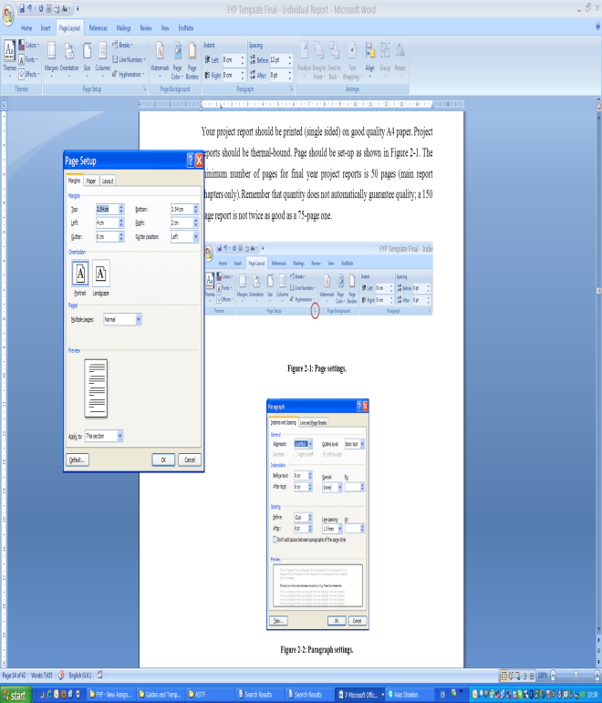
Figure ‎2-1: Page settings.
The body text of the whole document should be in 12 pt Times New Roman font, justified alignment, no indentation for first line in paragraphs, spacing before paragraphs 12 pt, and line spacing set at 1.5 lines; as shown in Figure ‎2-2.
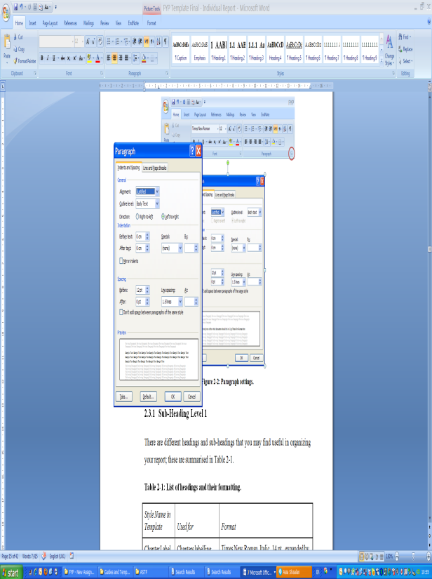
Figure ‎2-2: Paragraph settings.

Sub-Heading Level 1
There are different headings and sub-headings that you may find useful in organizing your report. Table ‎2-1 shows the different style names used in this template and when should it be used.
Also, the table shows the exact formatting for each of these styles, which can be useful if you are not using the template file for developing your document.
Table ‎2-1: List of headings and their formatting.
Style Name in Template | Used for | Format
Chapter Label | Chapters labelling | Times New Roman, Italic, 14 pt., expanded by 3.5, centred, space after: 24 pt., and page break before.
Heading 1 | Chapter title | Times New Roman, bold, 16 pt., all caps, centred, space before: 12 pt., space after: 36 pt., and outline numbered at level 1.
Heading 2 | Main headings | Times New Roman, bold, 14 pt., all caps, aligned to the left, space before: 18 pt., space after: 12 pt., and outline numbered at level 2.
Heading 3 | Sub-headings level 1 | Times New Roman, bold, 14 pt., title case, aligned to the left, space before: 12 pt., space after: 12 pt., and outline numbered at level 3.
Heading 4 | Sub-headings level 2 | Times New Roman, bold, 13 pt., title case, aligned to the left, space before: 12 pt. and space after: 12 pt.
Heading 5 | Sub-headings level 3 | Times New Roman, underlined, 12 pt., title case, aligned to the left, space before: 12 pt. and space after: 12 pt.

Figures and Tables
Use the word “Figure” (“Table”) even at the middle of a sentence when referring to a figure (Table) in text and make sure that all figures and tables are referred to. If your figure has two parts, include the labels “(a)” and “(b)” as part of the figure itself (do not use two different captions for each figure). Please verify that the figures and tables you mention in the text actually exist.
Do not put borders around the outside of your figures. Do not use color unless it is necessary for the proper interpretation of your figures. When re-sizing your figures, make sure that you use the same percentage for your figures height and width.
Use Times New Roman, 12 pt., aligned to the left, single line spacing and with space before: 6 pt. and space after: 6 pt. The style defined in this template for the text used in tables is “Body Text (Tables)”.

Figure Captions and Table Titles
Place figure captions below the figures; place table titles above the tables. Figure labels should be in Times New Roman, bold, 10 pt., and centered with 6 pt. spacing before and 24 pt. spacing after. Table titles should be in Times New Roman, bold, 12 pt., and left aligned with 12 pt. spacing before and 12 pt. spacing after.
The style defined for figure captions in the template is “Caption” and for table titles is “Table Caption”.

Numbering of Figures and Tables
All figures and tables must be numbered in their order of appearance in text. Also, the chapter number must be included in the numbering with a hyphen separating the chapter number and the figure/table number in that chapter. This is set through the caption dialogue box in MS Word as shown in Figure ‎2-3.
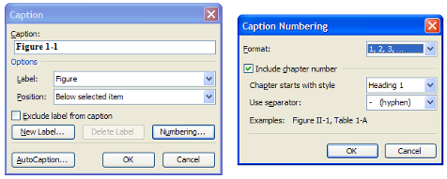
Figure ‎2-3: Setting caption numbering to include chapter number.

Referring to Figures and Tables in Text
When referring to figures and tables in your text you can use “Figure 1-1 shows…”, “as shown in Figure 1-1”, “(Figure 1-1)”, or “Table 1-1”.
The Cross-reference feature in MS Word can be used to insert references to figures, tables, and even different sections of your report as in the dialogue box shown in Figure ‎2-4.
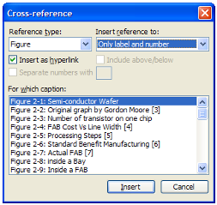
Figure ‎2-4: Using Cross-reference.

General Recommendations

Units
Using SI units as primary units are strongly encouraged. English units may be used as secondary units (in parentheses). An exception is when English units are used as identifiers in trade, such as “3½ in disk drive.” Avoid combining SI and English units, as this often leads to confusion because equations do not balance dimensionally. If you must use mixed units, clearly state the units for each quantity in an equation.

Abbreviations and Acronyms
Define abbreviations and acronyms the first time they are used in the text, even after they have already been defined in the abstract. Abbreviations such as SI, ac, and dc do not have to be defined. Abbreviations that incorporate periods should not have spaces: write “C.N.R.S.,” not “C. N. R. S.” Do not use abbreviations in the title unless they are unavoidable.

Equations
Number equations consecutively with equation numbers in parentheses flush with the right margin, as in (1). First use the equation editor to create the equation. Then select the “Equation” mark-up style. Press the tab key and write the equation number in parentheses. Use parentheses to avoid ambiguities in denominators. Punctuate equations when they are part of a sentence, as in
(1)
Be sure that the symbols in your equation have been defined before the equation appears or immediately following. Refer to equations as “Equation (1) is…”; even if it is in the middle of a sentence.

Other Recommendations
- Use one space after periods and colons. Hyphenate complex modifiers: “zero-field-cooled magnetization.” Avoid dangling participles, such as, “Using (1), the potential was calculated.” [It is not clear who or what used (1).] Write instead, “The potential was calculated by using (1),”
- Use a zero before decimal points: “0.25,” not “.25.” Use “cm³,” not “cc.” Indicate sample dimensions as “0.1 cm × 0.2 cm,” not “0.1 × 0.2 cm².”
- Do not mix complete spellings and abbreviations of units: use “Wb/m²” or “webers per square meter,” not “webers/m².”
- When expressing a range of values, write “7 to 9” or “7-9,” not “7~9.”
- A parenthetical statement at the end of a sentence is punctuated outside of the closing parenthesis (like this). (A parenthetical sentence is punctuated within the parentheses.) In American English, periods and commas are within quotation marks, like “this period.” Other punctuation is “outside”!
- Avoid contractions; for example, write “do not” instead of “don’t.”
- The serial comma is preferred: “A, B, and C” instead of “A, B and C.”
- If you wish, you may write in the first person singular or plural and use the active voice (“I observed that ...” or “We observed that ...” instead of “It was observed that ...”). However, passive voice is preferred.
- Remember to check spelling.

Codes and standards
The student must incorporate appropriate engineering standards and multiple design constrains such as cost analysis, economical study and environmental impact.
Examples for different engineering codes and standards:
Pipe Lines | ASME “American Society of Mechanical Engineers”
API “American Petroleum Institute”
Bolts | ISO “International Standard Organization”
ASTM “American Society for Testing and Materials”
Firefighting | NFPA “National Fire Protection Association”
Bearings | ISO “International Standard Organization”
FAG, SKF

Chapter Three

Answers to Frequently Asked Questions

What is the final year project?
The Final Year Project (FYP) consists of an individual piece of work of less than 40,000 words or 40-100 pages in length. A working title and a brief description of Projects will be provided by the department as well as the allocation of the most appropriate supervisor to each of these projects. Based on your requests and the criteria of allocation used by the department you will be allocated to one of these projects. After your first consultation with your supervisor, you may need to refine or to redefine your chosen subject area to ensure that it is manageable and feasible for an undergraduate student.
The supervisor who is allocated to you will have supervised many undergraduate projects before and is therefore in a good position to give you good general academic advice regarding the shape and general direction of your project. She or he may well know some of the specialist literature base that you intend to access and may be able to give you some advice and guidance along the way. However, it is not uncommon that students pick a subject area which accesses a wide range of literature with which the supervisor is not familiar – but this does not mean that your supervisor is not able to offer sound, general advice on project planning and writing.

Why is it important to you?
The Project counts for 5% of the total credit hours (9 credits out of a total of 180 credits) you need to complete to graduate and; hence, can greatly affect your GPA. In most cases your final year project grade and final report reflect your abilities to select, research, and present a substantial piece of work that displays your intellectual abilities to the full. A well-written project is a useful document to display to a potential employer when you enter the labour market. Also, the skills that you will have deployed are particularly useful should you wish to undertake work for a higher degree at Masters or at PhD level.
Moreover, the fact that you have researched and organised a substantial piece of work is a skill that you will be asked to deploy on many occasions in whichever career you choose to enter. You will have learnt to ‘project manage’ a substantial piece of work and learn the techniques associated with writing and assembling a large document and these skills will assist you when it comes to similar ventures in the future.

Why is it important to the college?
The Final Year Project (FYP) is one of the most important outcomes of the college activities. Most projects are application-oriented projects that are conducted with an industry partner to show competence in major academic area; such projects demonstrate your ability to apply knowledge, principles, and values to wider problems and issues. It also enables you to show and practice your intellectual, transferable, and practical skills. Through the implementation, presentation and just as importantly, the viva voce, the external world (both academic and industrial) will judge your calibre as one of our graduates.
Accordingly the college is responding to the importance of this educational product by setting up a procedure for the planning, control, and assessment of the projects. In fact, this guide is one of the actions taken by the college to ensure the quality and consistency of the final year projects throughout the different college departments.

How do I get allocated to a project?
Students should form groups of up to 4 students, so that these groups include at most one student from each category defined by the department.
Each group should complete a project wish list of three preferred projects based on the topics offered at the time of registration, and these projects should be put in order from the highest to the lowest priority.
Wish lists should be submitted by the group leader (the student with the highest GPA) to the professor responsible for the graduation projects at each department.
Individual students (with non-formed groups) will be placed in projects after all groups are settled down based on their wish lists, and available vacancies.
In case that more than one group has the same first wish project, priority will be given to the group of which the leader student has the highest GPA.

May I suggest a project?
You may suggest a project using the project proposal form found at the end of this document. You’ll need to form a group based on the criteria of groups formation mentioned earlier. You’ll also need a tentative title of the project and what you are planning to do. Also, you’ll need to state if you require any special equipment, industry partners, students or supervisors from other departments.
This proposal is reviewed by the department and if acceptable, supervisors are assigned to your project.

How do I get started?
Starting your projects requires you to have a solid knowledge and understanding of the project’s topic in general and of your project’s area of application in particular. So it is important to read quite widely around the area to locate a starting point for the project. Often you will find that a good starting point is the relevant chapter for a comprehensive and up-to-date textbook. You should also undertake more specialised literature searches using the resources of libraries, particularly CD-ROMS, databases, and the entire resources of the Internet. However, you do need to exercise a degree of care when using the Internet as there is no ‘quality control’ mechanism for material published on the Internet as there is for more conventional academic journals and the information you access may be inaccurate or not particularly relevant.
Chapter Four

Plagiarism
A key principle in submitting your final year project report is that appropriate acknowledgements be made for the contributions of others to any work that you used. The attribution of these sources should be in the form of standard referencing procedure that is described in more details in the next chapter.
Students who engage in such practices will be subject to academic sanctions, including a reduced or fail grade for their project. They may also be subject to administrative sanctions, including suspension or expulsion.

Definition of Plagiarism
Plagiarism is passing off the work of others as one’s own. It is defined by the act not the intention, so even careless accidental copying is still classed as plagiarism, for it gives the false impression that the student is the author and denies the genuine author their due acknowledgement.
To plagiarise is when you use the ideas or words of another person without giving them explicit credit. That 'other person' can be a published author, a person who completes assignments for others, or an internet source.

Dealing with Plagiarism

Plagiarism Levels
Different levels of plagiarism can be identified from mild to severe as follows:
- Plagiarism of a maximum of 15% of the literature review without appropriate referencing.
- Plagiarism of more than 15% of the literature review without appropriate referencing.
- Plagiarism of parts other than the literature review; for example, copying parts of the analysis, results, or discussion from previous students work.
- Plagiarism of complete parts of previous students work; for example, a whole chapter.

Academic Sanctions (Penalties/Actions)
One or more academic sanctions may be imposed for plagiarism. In cases of plagiarism levels 1 and 2; academic sanctions may be imposed by a project supervisor with the student’s agreement and without the involvement of any third parties. However; in cases of plagiarism levels 3 and 4; academic sanctions are imposed by a project supervisor and/or projects coordinator and/or head of department with the student’s agreement.
- Plagiarism Level 1: A specified reduction in the grade for the course.
- Plagiarism Level 2: A specified reduction in the grade for the course with re-submission of the report
- Plagiarism Level 3: A fail grade for part I or part II of the project.
- Plagiarism Level 4: A fail grade for part I and part II of the project with re-registration of a new project.

Identifying Plagiarism
The College of Engineering and Technology uses the Turnitin plagiarism detection software to support the detection of plagiarism. All students are required to check their documents using this software and to submit the detection results report to their supervisors before final submission of their work.
Supervisors then reviews the detection result report; if it is acceptable, supervisors use the Turnitin software to further analyze the final year project report and to grade the report. If it is unacceptable, the students may be asked to re-submit their report within a specified time frame or in severe cases (levels 3 and 4) a fail grade may be awarded to the course.

Chapter Five

citation and referencing
The report should be based on the student’s own work and in case of using any parts or copying any figures or diagrams from previous work this should be properly referenced according to the format explained below.
Clear referencing is vital both to avoid plagiarism and to allow the interested reader to follow up any of the works cited and read quotations in their original contexts.
A numbered list of references must be provided at the end of the report. The list should be arranged in the order of citation in text, not in alphabetical order. List only one reference per reference number.
Each reference number should be enclosed by square brackets. In text, citations of references may be given simply as “in [1] . . .” rather than as “in reference [1] . . .” Similarly, it is not necessary to mention the authors of a reference unless the mention is relevant to the text. It is almost never useful to give dates of references in text. These will usually be deleted by Staff Editors if included.
Footnotes or other words and phrases that are not part of the reference format do not belong on the reference list. Phrases such as “For example,” should not introduce references in the list, but should instead be given in parentheses in text, followed by the reference number, i.e., “For example, see [5].”

References Format
Sample correct formats for various types of references are as follows.
Books:
- G. O. Young, “Synthetic structure of industrial plastics,” in Plastics, 2nd ed., vol. 3, J. Peters, Ed. New York: McGraw-Hill, 1964, pp. 15–64.
- W.-K. Chen, Linear Networks and Systems. Belmont, CA: Wadsworth, 1993, pp. 123–135.
Periodicals:
- J. U. Duncombe, “Infrared navigation—Part I: An assessment of feasibility,” IEEE Trans. Electron Devices, vol. ED-11, pp. 34–39, Jan. 1959.
- E. P. Wigner, “Theory of travelling-wave optical laser,” Phys. Rev., vol. 134, pp. A635–A646, Dec. 1965.
- E. H. Miller, “A note on reflector arrays,” IEEE Trans. Antennas Propagat., tobe published.
Articles from Conference Proceedings (published):
- D. B. Payne and J. R. Stern, “Wavelength-switched passively coupled single-mode optical network,” in Proc. IOOC-ECOC, 1985, pp. 585–590.
Papers Presented at Conferences (unpublished):
- D. Ebehard and E. Voges, “Digital single sideband detection for interferometric sensors,” presented at the 2nd Int. Conf. Optical Fibre Sensors, Stuttgart, Germany, 1984.
Standards/Patents:
- G. Brandli and M. Dick, “Alternating current fed power supply,” U.S. Patent 4 084 217, Nov. 4, 1978.
Technical Reports:
- E. E. Reber, R. L. Mitchell, and C. J. Carter, “Oxygen absorption in the Earth’s atmosphere,” Aerospace Corp., Los Angeles, CA, Tech. Rep. TR-0200 (4230-46)-3, Nov. 1968.

References to Electronic Sources
The guidelines for citing electronic information as offered below are a modified illustration of the adaptation by the International Standards Organization (ISO) documentation system and the American Psychological Association (APA) style. Three pieces of information are required to complete each reference: 1) protocol or service; 2) location where the item is to be found; and 3) item to be retrieved. It is not necessary to repeat the protocol (i.e., http) in Web addresses after “Available” since that is stated in the URL.
Books:
- J. Jones. (1991, May 10). Networks. (2nd ed.) [Online]. Available: http://www.atm.com
Journals:
- R. J. Vidmar. (1992, Aug.). On the use of atmospheric plasmas as electromagnetic reﬂectors. IEEE Trans. Plasma Sci. [Online]. 21(3), pp. 876–880. Available: http://www.halcyon.com/pub/journals/21ps03-vidmar
Papers Presented at Conferences:
- PROCESS Corp., MA. Intranets: Internet technologies deployed behind the firewall for corporate productivity. Presented at INET96 Annu. Meeting. [Online]. Available: http://home.process.com/Intranets/wp2.htp
Reports and Handbooks:
- S. L. Talleen. (1996, Apr.). The Intranet Architecture: Managing information in the new paradigm. Amdahl Corp., CA. [Online]. Available: http://www.amdahl.com/doc/products/bsg/intra/infra/html
Computer Programs and Electronic Documents:
- A. Harriman. (1993, June). Compendium of genealogical software. Humanist. [Online]. Available e-mail: HUMANIST@NYVM Message: get GENEALOGY REPORT

References
This document is based on other final year project guides; these are:

Appendices

- Project Request and Proposal Forms
- Request for Funding Forms
- Project Abstract Forms
- Students Evaluation Forms

