r

Arab Academy For Science , Technology and Maritime Transport

Thermal designs of hydraulic systems

DR : Rola
Name :- Abdelrahman Mohamed Zaki
Reg :- 22127305

Thermal Analysis of Sequence Hydraulic System
The system of hydraulic has a smooth transmission, compact structure, small size,
overload protection, bearing capacity and other features, so it is usually utilized in the industrial field. When the hydraulic oil temperature increases, the leakage will increase in the hydraulic system, causing the effect of control stability and accuracy, therefore, become a fundamental cause for the limitation of hydraulic technology. It is therefore essential to analyze the thermal system of the hydraulic system to control the oil temperature of the hydraulic system in the permissible range. Therefore, the thermal cause of the hydraulic system is difficult and complicated so that it will consume energy and time. The change in viscosity with temperature. The higher the viscosity index, the decrease the sensitivity of viscosity to temperature. They observed that when the fluid temperature rises, the effective bulk agent of the liquid reduces, reducing the bulk factor directly to reduce the significant fluid hardness, and hydraulic motors are sensitive to temperature changes with time. An analysis was performed to determine the effect of process variables on oil viscosity and studied the influence of time, pressure and temperature on the viscosity of various lubricant specimens. The method of prediction was applied to a real hydraulic system. The oil flow dynamics were designed with a one dimensional heat generation mechanism using ordinary differential equations . The fundamental approaches of modelling thermal-hydraulic component briefly. A mathematical model of lumped factor set is advanced that are depending on the conservation of energy and. mass. The influence of temperature-oil and pressure changes on the efficiency of the hydraulic system at different temperature and pressure levels was studied by Hassan and Ibrahim. The viscosity of the oil was found to rely mainly on the temperature and the influence of the strain on the viscosity that could be easily seen at low temperatures. The increasing temperature in the neutral circuit is quicker and more generous than that in the charging circuit, where the oil temperature at the tank approaches (59.1 ° C) for the neural circuits and (52.4 ° C) for the loading circuit at a pressure of 40 bar with the same period (240 min). The proportion was 11.33%. The pressure losses proportion in the neutral and loading circuit measurements with a 40 bar pressure at the same period of (240 min) are 10.2 percent and 11.65 percent, respectively, leading to further loading circuit losses. The efficiency of the machine depends primarily on the temperature and operating time. Lahari and Reddy [8], intended to minimize the excessive oil temperature by adjusting the construction, the tank material, supplying fins over it and increasing the performance of the power pack by minimizing heat losses, were examined and analyzed Understanding of the work was evaluated using the design expert program, and the error was just 0.01 per cent where the work was evaluated utilizing less than 0.05 percent indicates model terms are essential. The direct-driven hydraulic test rig without control valves was identified by Tatiana Minav el.at, who researched it from a thermal viewpoint. The relation between the outcome of the simulation and the test results validates the models advanced for the hydraulic system. The experimental tests suggest temperature increase throughout the lifting period, and it was treated throughout lowered. The energy analysis approach examined by Chao Wu et al. is utilized to evaluate the heating of the constant-pressure device to assess the technical condition of the hydraulic parts, and the heat source is correctly discovered that has significant practical importance. The hydraulic system's heating value is related to the decrease in pressure and flows through the system. The hydraulic system heat source could be reliably discovered by calculating the applicable data and comparing it with the sample data. The starting pressure of a safety magnitude needs to be set higher than that of an outlet port pump for the constant-pressure system. However, a high-pressure overflow anomaly could occur, resulting in heating of the area. Hydraulic pipe track with a minimal diameter causes significant pressure loss, quickly contributes to system heating. Hence a fair selection of pipeline diameter is critical. The thermal device model was rational, and it was able to forecast the temperature increase of fluid temperature and research the thermal aspects of a hydraulic method, heat production and dissipation to approximate the temperature rise and steady-state temperature profile. Badrinarayanan et al. studied the hydraulic system of land gear. A steady-state theoretical temperature of approx. After about one hour of activity, the temperature increase of the machine was inside limits (71 C0) following half an hour of experimental activity (62.51 ° C)

- Types of thermal hydraulics :-
- Computational fluid dynamics
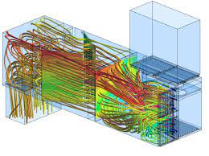
is the use of applied mathematics, physics and computational software to visualize how a gas or liquid flows as well as how the gas or liquid affects objects as it flows past. Computational fluid dynamics is based on the Navier-Stokes equations. These equations describe how the velocity, pressure, temperature, and density of a moving fluid are related

- Heat exchangers
HE are key equipment in cryogenic systems. Thermodynamic and economic considerations set high-efficiency requirements which result in the need for accurate models.
Cryogenic systems involve two main challenges for the modeling of HE: complex processes and non-negligible physical effects. The complexity of the processes include large temperature ranges, multiple streams, two-phase flow.
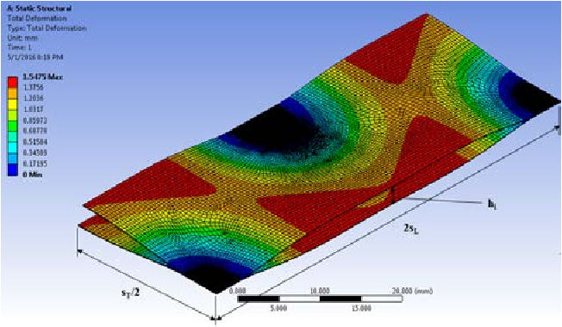

- Neutronics
Thermal neutrons are produced by slowing down more energetic neutrons in a substance called a moderator after they have been ejected from atomic nuclei during nuclear reactions such as fission.

Heat Gain of Hydraulic system
Heat is obtained from external sources in case of a cold beginning environment of a hydraulic system, through different losses and from components.

Gained heat from the heating :-
In a cold start environment, some heating of fluid is provided to obtain certain
temperatures. The heat gain from heating is:
𝑃𝑊 = 𝑉𝑇 𝐶 𝜌 $\frac{T1-T2}{h}$
Where
𝑃𝑊- Heat flow in W
𝑉𝑇- Volume of oil in a tank in Litter
C - Specific thermal capacity in kJ/kg K
𝜌 - Average of density in kg/ m3
𝑇1, 𝑇2 - Temperatures in K
H - Time of heating in h
Properties of oil hydraulic
𝜌 = 890 kg/m3
𝑐 = 4.7 kJ /kg K
Due to the temperature of the low surroundings, you must maintain a fixed emperature for the system that loses heat.
𝑄𝑤 = 𝑘 𝐴 (𝑇1 − 𝑇2)
Where as
𝑄𝑤- Gained Heat of Required W
𝑘 - Coef. convection of heat transfer in kW/m2K
𝐴 - Area of Heat dissipation in m2
𝑇1, 𝑇2- Oil Temperatures and surroundings respectively in K

Gained Heat from Losses
The entire power losses of the hydraulic sequence system consist of several losses shown as
follows:
𝑃𝑡𝑜𝑡𝑎𝑙 = 𝑃𝑙.1 + 𝑃𝑙.2 + 𝑃𝑙.3 + 𝑃𝑙.4 (3)
Where
𝑃𝑙.1- Losing of Power because of components’ efficiencies.
𝑃𝑙.2 - Losing of Power because internal leakages
𝑃𝑙.3 – Losing of Power because throttling
𝑃𝑙.4- Losing of Power because flow resistance
𝑃𝑙.1 = $p_{pump}$=$\frac{V p}{600}$($\frac{1}{η}$-1)
𝑉 = Total flow rate in Litter/min
p = pressure of operating in bar
𝜂 = Total efficiencies
𝑃𝑙.2 =$\frac{V p}{600}$

𝑉𝑙 - Inner leakage in Litter/min
Δ𝑝- Pressure drop in bar
𝑃𝑙.3 = ∑$\frac{v_{t} p_{t}}{600}$
𝑉𝑡- Flow rate of a valve in Litter/min
𝑝𝑡- Pressure drop at the valve in bar
𝑃𝑙.4 =$\frac{v_{t∑} p_{t}}{600}$
V- Total flow rate in Litter/min
∑ Δ𝑝- Total of all pressures in bar

Heat losing out of components :-
Heat losing occurs out of the hydraulic system components, the tank, pipe, and heat exchanger at a rate consist of the surface-area, fluid velocity and thickness of the wall.

Thermal balance and temperature profile:-
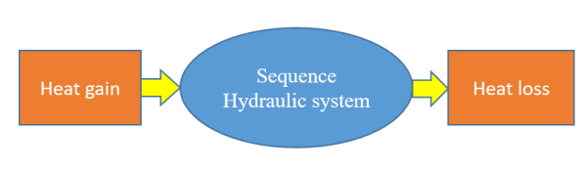
The oil-hydraulic temperature count on losses of power, the surface area of thermal radiating and installation place. Also, the most significant permitted oil temperature count on the kind of oil, the system required, and the duty cycle of the operation. Compare gained thermal to thermal loss, the consequent be the temperature recollected by the system through time. This thermal gathering intends to increase the oil temperature, which is assessed
Figure 1. Thermal balance of Hydraulic system.

Heat Balance Calculation :-
In heat transfer analysis, assuming Lumped system analysis is a great convenience. But for using it, an appropriate criterion is to be satisfied. The foremost parameter for checking the validity is the Biot number, Bi. Biot number is the ratio of the surface convection to the conduction within the body and the degree of validity of Lumped system analysis is inversely proportional to the value of Bi.
Thermal design of a hydraulic system involves analyzing the heat transfer mechanisms and ensuring that the system components are operating within their temperature limits. The main components that can generate heat in a hydraulic system are the pump, motor, valves, and actuators. The heat generated by these components can affect the viscosity of the hydraulic fluid, increase the wear and tear on the system components, and reduce the overall efficiency of the system.

Biot Number.
Biot number, Bi = hLc / k
Where h = heat transfer coefficient in W/m2K
Here are some steps you can follow to design a thermal hydraulic system:
Lc = Characteristic Length
K = Thermal conductivity in W/mk
Characteristic length, Lc = Volume / Area
Total volume of the system = Vpump + Vreservoir + Vmotor + VTubing + VActuator + VFilters
Experimental work :-
Laboratory hydraulic preparation and minimal seat testing were completed with readily available materials. The circuit's relationship to the fundamentals requirement did not change. However, due to pipes' limited availability, the length of the pipe was constrained. An electric motor using a 24 volt DC power supply powered the hydraulic pumps. The system operated in accordance with its functional specifications, and the rise in liquid temperature in the tank was observed. Figure 2 and Table 2 show the laboratory environment and the experimental instrument, respectively. The system was operated for 30 minutes at room temperature, and the temperature rise of the liquid was gauged from the tank during the test.
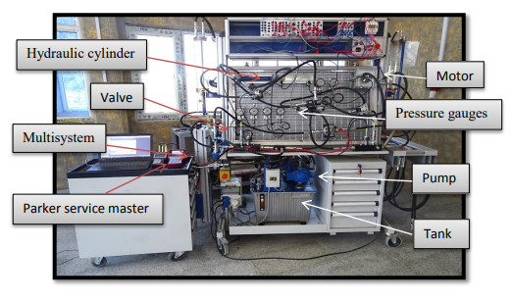

Figure 2. Laboratory testing system.

Table 2. Specification device used in the experiment
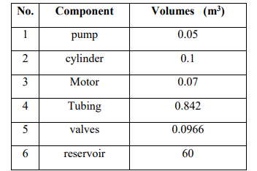

Results & Discussion :-
The experimental work includes estimating the increase in oil temperature in the sequential hydraulic system in order to shorten the period of system exhaustion caused by the rise in oil temperature. The experimental study comprised the behaviour of the temperature profile with varying flow rates (Q=3, 5, 7 l/min) and three variable pressures of the system (P=40, 50, 60 bar), as well as changing the duration the hydraulic motor operated (t=2, 5, 10 seconds). The experimental work was carried out by examining the impact of three ambient temperatures (T=20, 30, and 40oC) on the temperature rise of the hydraulic system.
The Effect of Flow Rate:-
Figure (3) shows the oil temperature inside the reservoir as a function of operation time and flow rate. It shows that the temperature increased to the steady value 49. 9 oC, when the flow rate increase at 7 l/min, while the value of the steady temperature was( 42.3 and 34.9 oC) at flow rate 5 and 3 l/min, respectively. The percentages of increasing the temperature were (36%, 48%, 55%) at the flow rate (3, 5, and 7 l/min) respectively. The higher the flow rate the greater temperature due to the increased velocity of flow furthermore.
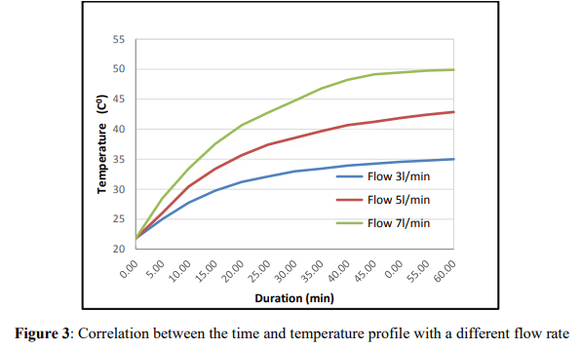

The Effect of Setting Pressure :-
Figure (4) represents the temperature progressively increasing until it reached a steady value of 42.66 oC after one hour at a pressure of 60 bar. The temperature attained a stable state (35.9, 39.33 oC) when under pressure (40 and 50 bar, respectively). At pressures of 40, 50, and 60 bar, the percentages of increasing temperature were (39%, 44%, and 49%), respectively.As a result of increased heat generation through components, pressure drop across components increases.
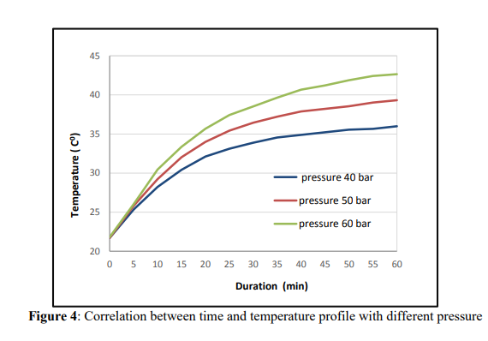

The Effect of Duty Time:-
Figure (5) depicts all of the temperatures inside the tank, beginning at 23 oC and rapidly increasing to higher values (35, 38, and 40.9 oC) at different time intervals (2, 5, and 10 seconds). At duty times of 2 seconds, 5 seconds, and 10 seconds, the percentages of temperature increase were (33%, 38%, and 43%), respectively. Affects on two sides: first, temperature rises due to increased heat generation by the hydraulic motor; second, temperature falls due to increased heat dissipation by the tank.
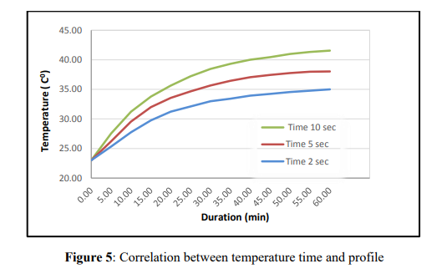

The Effect of ambient temperature :-
Figure 6 illustrates a comparison of the ambient temperatures at which the oil reaches the reservoir and the operating time. The temperature of the oil entering the reservoir begins at 20 oC and gradually rises to a steady value of 40.9 oC when the ambient temperature is 20 oC, and when the ambient temperature is 30, 40 oC, the temperature of the oil entering the reservoir (30, 40 oC) reaches steady temperature values of 52, 61.8 oC, respectively. This temperature increases due to heat generation were the additional increase in temperatures at the intake 20, 30, and 40 oC is 10 oC. While the increase in temperature at the outlets 40.9, 51.7, and 62 is also 10 oC, this is due to equal heat dissipation.
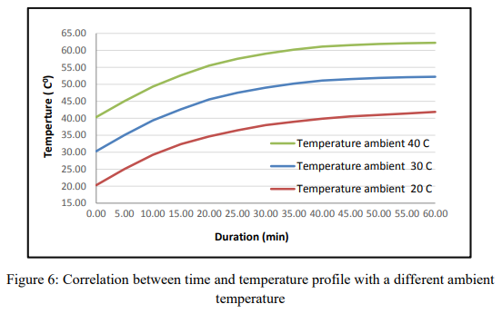

Conclusion:-
This study estimates oil temperature and how it affects hydraulic system pressure, flow rates, duty time, and ambient temperature. During the investigation, the hydraulic system has been calculated for various heat factors, and temperature degrees have been determined: 1- At the flow rates of 3,5 and 7 l/min, the percentages of increasing the temperature were (36%, 48%,and55%),respectively. 2- Increasing heat generation through components increases pressure between components. 3- The percentages of temperature increase were (33%, 38%, and 43%) for duty times of (2, 5, and 10 seconds).

1. Determine the heat load: Calculate the heat load generated by the hydraulic system by adding up the power losses of all the components. The power losses can be calculated using manufacturer data or by testing the system.
2. Calculate the required heat dissipation: Determine the amount of heat that needs to be dissipated from the system to maintain the components within their temperature limits. This can be calculated using the thermal resistance of the system components and the ambient temperature.
3. Select appropriate cooling methods: Choose the appropriate cooling methods based on the available space, cost, and the amount of heat that needs to be dissipated. Common cooling methods include air cooling, water cooling, and oil cooling.

4. Design the heat exchanger: Design the heat exchanger based on the cooling method selected. The heat exchanger should be sized to match the heat load generated by the system. The heat exchanger should also be designed to minimize pressure drop and optimize heat transfer.
5. Select appropriate materials: Choose materials that can withstand the high temperatures and pressures of the hydraulic system. The materials should also have good thermal conductivity to facilitate heat transfer.
6. Consider the effects of fluid properties: The viscosity of the hydraulic fluid can change with temperature, affecting the flow rate and pressure in the system. Consider the effects of fluid properties on the system performance and design accordingly.

7. Test and validate the system: Finally, test and validate the system to ensure that it operates within its temperature limits and that the cooling system is effective in dissipating the heat generated by the system

