

We certify that we have read the present work and that in our opinion it is fully adequate in scope and quality as a thesis towards the partial fulfillment of the Master's Degree requirements in
Mechanical Engineering
Mahmoud Ahmed Mahmoud Abdelhamid Mohamed

Supervisor:

Name:
Position: Signature:
Examiners:

Name:
From
College of Engineering and Technology

AASTMT
Date : 17/04/2024

Ass. Prof. Rola Afify
Associate Professor, Mechanical Engineering Department, College of Engineering and Technology, Alexandria

Prof. Hassan El-Gamal

Position: Signature:

Professor, Mechanical Engineering Department, Alexandria University

Name: Position: Signature:

Prof. Ahmed Hanafy
Professor, Mechanical Engineering Department, College of Engineering and Technology, Alexandria

Name: Position: Signature:
Ass. Prof. Rola Afify
Associate Professor, Mechanical Engineering Department, College of Engineering and Technology, Alexandria

DECLARATION
I certify that all the material in this thesis that is not my own work has been identified, and that no material is included for which a degree has previously been conferred on me.

The contents of this thesis reflect my own personal views, and are not necessarily endorsed by the University.
Name
Mahmoud Ahmed Mahmoud Abdel-hamid Mohamed
Signature ..............................................................................................
Date
...............................................................................................



Arab Academy for Science, Technology and Maritime Transport

Higher Studies Department Mechanical Engineering Department

ENERGY LOSS THROUGH ORIFICE FOR WATER & NANO-FLUID

By

Mahmoud Ahmed Mahmoud Abdel-Hamid Mohamed

A Case study submitted to AASTMT in partial Fulfillment of the requirements for the award of the degree of

MASTER'S OF ENGINEERING
in MECHANICAL ENGINEERING

Supervisor

Ass. Prof. Rola Afify
Associate Professor, Mechanical Engineering Department, College of Engineering and Technology
AASTMT _ Alexandria
2024

Declaration
I declare that this Case study is an original report of my research, has been written by me and has not been submitted for any previous degree. The experimental work is almost entirely my own work; the collaborative contributions have been indicated clearly and acknowledged. References have been provided on all supporting literatures and resources.

Acknowledgements
I would like to thank all the people who contributed in some way to the work described in this Case study. First and foremost, I thank our academic advisor, Dr. Rola Afify, for accepting me. During my tenure, they contributed to a rewarding graduate school experience by giving me intellectual freedom in my work, engaging me in new ideas, and demanding a high quality of work in all my endeavors. Finally, I send my deepest thanks to my family who always supports me.

Abstract

Numerous factors related to the utilization of Nanofluid developments remain unresolved. Generally, nanofluids are commonly utilized to enhance heat transfer rates. There are still limitations and drawbacks in the development of nanofluids. The use of nanofluids increases fluid flow resistance, resulting in higher losses and reduced flow rates. The purpose of this case study is to investigate loss coefficient of Al2O3 nanofluid through an orifice at different flow rates.
The single-phase numerical method using ANSYS 2019 R3 was employed to predict flow characteristics through the orifice plate. Mesh independency is verified. Outcomes of the CFD simulations in terms of profiles of velocity and pressure for water and Al2O3 nanofluid is discussed in detail. The results of water are first validated with other published paper.

Table of Contents
DECLARATION I
ACKNOWLEDGEMENTS II
ABSTRACT III
TABLE OF CONTENTS… IV
LIST OF FIGURES V
LIST OF TABLES VI
- CHAPTER ONE : INTRODUCTION 1
  - INTRODUCTION 1
  - ` NANO FLUIDS 1
  - IMPACT OF DIFFERENT FACTORS ON THERMAL CONDUCTIVITY 3
  - APPLICATIONS OF NANOFLUID 5
  - DRAWBACKS OF NANOFLUIDS 6
  - PIPE FITTINGS 7
  - JOINING PIPE FITTINGS 10
  - VALVES TYPES 11
  - PRESSURE DROP IN PIPE FITTINGS 14
  - PUMPING POWER 19
- CHAPTER TWO : LITERATURE REVIEW 20
  - INTRODUCTION 20
  - NANO FLUIDS 21
  - NANOFLUID PREPARATION 22
  - THE IMPACT OF NANOFLUIDS ON FRICTION FACTORS IN PIPES 22
  - PUMPING POWER IN NANOFLUIDS 24
  - PIPES AND FITTINGS FRICTION LOSSES 24
  - APPLICATIONS OF NANOFLUIDS 26
- CHAPTER THREE : CFD SIMULATION OF NANO-FLUIDS 27
  - INTRODUCTION 27
  - GOVERNING EQUATIONS AND MODELLING ASSUMPTIONS 27
  - GEOMETRY, GRID AND COMPUTATIONAL DOMAIN 28
  - NUMERICAL PROCEDURE USING CFD 30
  - RESULTS AND DISCUSSION 36
- CHAPTER FOUR : CONCLUSION AND FUTURE WORK 38
  - CONCLUSION 38
  - FUTURE WORK 38
REFERENCES 40

List of Figures

1-1 | One step preparation process of nanofluids…………………………………………………………… | 3
1-2 | Nanofluid Preparation - Two Step Method ..………………………………………………………….. | 3
1-3 | Pipe fittings …………………………………………………………………………………………………………… | 7
1-4 | Different shapes of orifice plates …………………………………………………………………………… | 8
1-5 | Elbows configuration …………………………………………………………………………………………….. | 8
1-6 | Difference between Swept Tee & Wye Tee ……………………………………………….…………… | 9
1-7 | Difference between concentric and eccentric reducers ………………………………………… | 9
1-8 | Unions ………………………………………………………………………………………………………………….. | 10
1-9 | Difference between Cap & Plug …………………………………………………………………………….. | 10
1-10 | Manual Ball Valve ………………………………………………………………………………………………….. | 12
1-11 | Butterfly Valve ………………………………………………………………………………………………………. | 12
1-12 | Cross- section for the Globe Valve …………………………………………………………………………. | 13
1-13 | Check Valve Cross section View …………………………………………………………………………….. | 14
1-14 | Safety Valve …………………………………………………………………………………………………………… | 14
1-15 | K factors for misc. pipe fittings ………………………………………………………………………………. | 18
3-1 | The Orifice Geometry ……………………………………………………………………………………………. | 28
3-2 | 2D Mesh of the computational domain with mesh elements (a) 325,384 and (b) 15,865 …………………………………………………………………………………………………………………… | 30
3-3 | Loss coefficient changing with number of mesh elements …………………………………….. | 31
3-4 | 2D Mesh of the computational domain M5 with mesh elements 148,092 …………….. | 31
3-5 | Pressure Drop Profile (a) Tukiman et al. [59] and (b) Case Study …………………………… | 32
3-6 | Velocity Vectors Profile (a) Tukiman et al. [59] and (b) Case Study ………………………… | 33
3-7 | Velocity Contour Profile (a) Tukiman et al. [59] and (b) Case Study ……………………….. | 34
3-8 | Centerline Axial Velocity (a) Tukiman et al. [59] and (b) Case Study ………………………. | 35
3-9 | Variation of Pressure drops with Flow rate for Al2O3 Nano-fluid and Water …………. | 36
3-10 | Loss coefficient variations with Flow rate for water and Al2O3 nanofluid ……………… | 37
3-11 | Variation of Pressure drops with Flow rate for Al2O3 Nanofluid and Water …………… | 37

List of Tables

3-1 | Thermo-physical properties of Al2O3 nanoparticles ………………………………………………… | 29
3-2 | Thermophysical properties of water and of Al2O3 …………………………………………………… | 29

Chapter One

1 INTRODUCTION

INTRODUCTION

Energy saving and cost control had become the whole world main concern nowadays. Industrial technologies and manufacturing are keen on miniaturization, sustainability and higher energy efficiency of equipment which achieve this target. Several ways were utilized to reduce frictional loss, pressure drop and pumping power. High pumping power and high thermal loads are the main obstacles which stand in front of the common fluids, mainly because of their poor thermophysical properties.

Nanofluids with an optimal design are suggested as a promising solution that have obvious improvement in heat transfer enhancement but the development of nanofluids is still limited by various drawbacks mentioned previously. The purpose of the current case study is to examine the effect of nanofluids on pressure drop and compare the results with those of water.

NANOFLUIDS

Nanofluid is a fluid containing nanometer sized particles, called nanoparticles. They exhibit enhanced thermal conductivity and the convective heat transfer coefficient compared to the base fluid was discussed by Mukherjee et al. [1]. The nanoparticles used in nanofluids are typically made of metals, oxides, carbides, or carbon nanotubes. Common base fluids include water, ethylene glycol and oil, Buongiorno et al. [2].
Nanofluids have novel properties that make them potentially useful in many applications in heat transfer, Minkowycz et al. [3] including microelectronics, fuel cells, pharmaceutical processes, and hybrid-powered engines, Kim et al. [4] engine cooling/vehicle thermal management, domestic refrigerator, chiller, heat exchanger, in grinding, machining and in boiler flue gas temperature reduction. They exhibit enhanced thermal conductivity and the convective heat transfer coefficient compared to the base fluid, Kakaç et al. [5]
Chavda et al. [6] investigated friction factor CuO/water nanofluid on different pipe and found that friction factor increases when volume concentration of CuO/water nanofluid increases. The increase in effective thermal conductivity and the variations of other thermophysical properties contribute in the enhancement of heat transfer. On the other hand, there are not enough studies conducted for nanofluids with careful consideration for scaling effects on the flow. More careful and systematic experimental investigations on the thermophysical properties of the different types of nanofluids are

required in parallel with any investigation on their heat transfer and fluid flow through heat the exchangers to determine the overall efficiency of the system. Also, sensible consideration should be taken into account to the pollution and toxicity impacts of the nanoparticles on the environment and health, besides other factors such as the cost of the nanoparticle type, the negative impact on pressure drop of the flow and the total energy efficiency of the system.

Nanofluid preparation

Nanofluids are prepared by mixing nanoparticles in the base fluid usually water. Good dispersion is essential for most of nanofluid applications. Surfactants are used sometimes to increase the nanofluids stability. There are two fundamental methods to prepare nanofluids which are one step and two-step physical. Chemical process is another emerging technology in preparation of nanofluids.
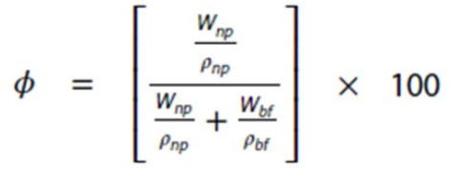
The percentage of volumetric concentration is calculated from the Eq. (1-1)

(1-1)

Where:

ϕ is the volumetric concentration Wnp is weight of nanoparticles, Wbf is weight of base fluid,
ρnp is density of nanofluid, ρbf is density of base fluid

One step Method

The one step method consists of making and dispersing the nanoparticles in the base fluid at the same time. Many steps like drying, storage, transportation and dispersion of nanoparticles are done away within this process; this reduces the agglomeration considerably and increases the stability of the nanofluid. One step method is highly successful in dispersing the nanoparticles uniformly and provides greater stability. One step method has not been successful in preparing nanofluid on a big scale and the production costs are also high. Zhu et al. [7] prepared Cu nanofluid one-step method. One step preparation process of nanofluids is shown in figure 1-1.

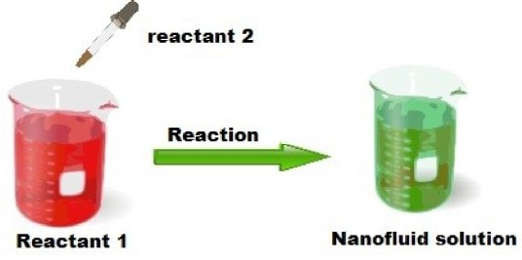

Figure 1-1: One step preparation process of nanofluids [1]

Two Step Method

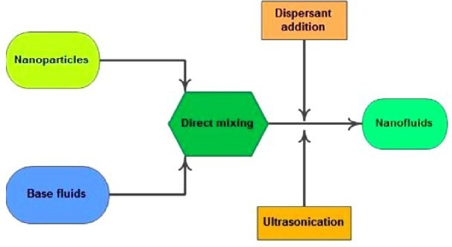
The most common method used for the preparation of nanofluid is two step method. Nanomaterials are made into a dry powder using physical or chemical means. The next step involves the dispersion of nano sized powder into a base fluid using magnetic force agitation, ultrasonic agitation. Nanoparticles have the tendency to agglomerate owing to the large surface area and surface activity. Surfactants are used to prevent this and the behavior of the surfactants at high temperature also comes into play. It is quite difficult to prepare stable nanofluid using the two-step method. Zhu et al. [7] used two step method to prepare Al2O3/water nanofluid. Figure 1.2 demonstrates the two-step method.

Figure 1-2: Nanofluid Preparation - Two Step Method [1]

IMPACT OF DIFFERENT FACTORS ON THERMAL CONDUCTIVITY

Thermal conductivity of nanofluid largely depends on the type of base fluid, type of nanoparticles, particle size, particle shape, and temperature.

Base fluid

Thermal conductivity of nanofluid depends on the thermal conductivity of the base fluid. Nanofluid possesses higher the thermal conductivity if the thermal conductivity of the base fluid is high.

Nanoparticles

Generally, metal oxides are used as the dispersed particles in the base fluid because of its chemical stability. In addition, pure metal is expensive. The thermal conductivity of nanofluid depends on the type of nanoparticles used in the base fluid. Nanoparticles are preferred which possesses high thermal conductivity.

Nanoparticles concentration

Thermal conductivity of nanofluid increases if the nanoparticle concentration increases, Sundar et al. [8]. Most of the effective thermal conductivity model provided by the researchers are based on the nanoparticle concentration. Both the linear and the non-linear relationship between thermal conductivity and nanoparticular concentration was established by researchers. Zhu et al. [9] found nonlinear relationship in case of Fe2O3/water nanofluid. Barbés et al. [10] studied CuO nanofluid and found a linear relationship. A nonlinear increase in thermal conductivity of MWCNT nanofluid was found by Ding et al. [11]. Xie et al. [12] also found nonlinear relationship in case of glycol-based CNT nanofluids.

Particle size

Nanofluid is prepared by nanoparticles with diameter of 1–100 nm. Thermal conductivity of nanofluid also depends on the size of nanoparticles and has an inverse relationship Akilu et al. [13]. The thermal conductivity of nanofluids gets improved with the decreased nanoparticle size. If the particles are of small size, Brownian motion becomes prominent. Hence, chaotic movement increases in the base fluid. Hence, thermal conductivity of nanofluids gets increased. The surface to volume ratio increases if the size of particle decreases Kazemi et al. [14]. Teng et al. [15] investigated the effect of Al2O3 nanoparticles size on the thermal conductivity of Al2O3/water nanofluid. Enhancement of thermal conductivity was found in their investigation.

Particle shape

Hamilton-Crosser equation of thermal conductivity demonstrates that thermal conductivity also depends on the shape of nanoparticles. Shape of the particles may be different types like spherical,

cylindrical or rod type, blade, brick type shapes and so forth. Effect of particle shape on Al2O3/EG- water was investigated by Timofeeva et al. [16] and found that cylindrical shaped nanoparticles possess highest thermal conductivity. Brick shaped nanoparticles possess higher thermal conductivity than platelet and blade shaped nanoparticle Kim et al. [17].

Temperature

Thermal conductivity of nanofluid is the temperature dependent property Duangthongsuk et al. [18]. Researchers have found improved thermal conductivity of nanofluid with the increase in temperature. Brownian motion is liable because of this enhancement. Thermal conductivity increases with the increase in temperature as Brownian motion gets more vigorous. Das et al. [19] investigated Al2O3/water and CuO/water nanofluid and found improved thermal conductivity with the increase in temperature. Li et al. [20] found the same result with Al2O3/water nanofluid. Duangthongsuk et al.
[21] carried out experiment on TiO2/water nanofluid with temperature between 15–30 °C and found increased in thermal conductivity.

Surfactant

Surfactants are used to enhance the stability of nanofluid by reducing agglomeration of nanoparticles. Surfactants reduce thermal conductivity of nanofluid, while improving stability. Khairul et al. [22] researched CuO/water nanofluid with SDBS surfactant and discovered that thermal conductivity decreases after the addition of surfactant. Nanofluid thermal conductivity decreases with an increase in surfactant concentration. Surfactant has lower thermal conductivity than the base fluid. As a result, effective thermal conductivity reduces. Therefore, surfactant should be used at optimum concentration.

APPLICATIONS OF NANOFLUID

    - Heat exchanger

Different types of heat exchanger including shell and tube, plate type, microchannel type, compact, and so forth are being widely used in the heavy industry, processing industry, etc. Recently, researchers are trying their utmost to increase the heat transfer performance of heat exchanger by substituting traditional heat transfer fluid with nanofluid Sajid et al. [23].

Transportation cooling system

Automotive and heavy-duty engines are associated with a plethora of heat. Engine may get damaged if this unwanted heat is not dissipated rapidly. For the first time, Choi et al. [24] suggested to use nanofluid in automotive cooling system. Al2O3/water nanofluid enhances heat transfer up to 45% in the car radiator than pure water Peyghambarzadeh et al. [25].

Industrial cooling

In power generation industry, transformer cooling is important. Kulkarni et al. [26] applied Al2O3 nanofluid as jacket water coolant in a diesel electric generator to dissipated excess heat. Researchers are relentlessly giving their effort to reduce transformer size and weight by enhancing cooling system.

Electronics equipment

Sardarabadi et al. [27] conducted an investigation of sodium carbon nanotube (Na-CNT/water) and Potassium carbon nanotube (K-CNT/water) nanofluid in two-phase closed thermosyphon (TPCT) for the purpose of electronic chip cooling. Na-CNT/water nanofluid showed higher thermal efficiency than K- CNT/water nanofluid.

Refrigeration

Mohan et al. [28] conducted an experimental analysis on energy performance of Vapor Compression Refrigeration System (VCRS). The outcome of their research was tremendous in the nanofluid research in refrigeration. Compression work reduces with the increase in volume fraction of nano- lubricant which enhance the coefficient of performance (COP).

DRAWBACKS OF NANOFLUIDS

- Sophisticated equipment is used to produce nanoparticles. Hence, production cost of nanofluid is high.
- Stability of nanofluid is poor without surfactant.
- Pressure drop and pumping power is increase with the increase in the density and viscosity of fluid. Density and viscosity of nanofluid is much higher than the base fluid. Hence pressure drop and pumping power of nanofluid is also higher than the base fluid.

PIPE FITTINGS

To begin with studying nanofluids effects through pipes and pipe fittings a detailed review will be carried out in order to complete this task. Pipe fittings are an important component of any engineering application, joining many types of fixtures together are used to form a successful system as per application requirement. Piping main components are elbow, union, gasket, joints and valves, these are the most commonly used while carrying out any application or tasks. These fittings are applied in the piping system to be able join straight pipes or any section of tubes. In other words, these components are fitted together to either change the direction of flow or distribute the flow from the supply source (main pipe) to other pipes of equal size or lower size, etc. also to maneuver the flow depending on the used application. Many researches are conducted for proper engineering and installation of the piping system to ensure the cost effectiveness of the system.

Pipe Fittings Types

Different types of pipe fittings are employed in piping systems. Elbows, reducers, tees, couplings, unions, caps, crosses, plugs, adapters, valves, outlets, flanges, and orifice plate are the most important and commonly used items as shown in figure 1-3.

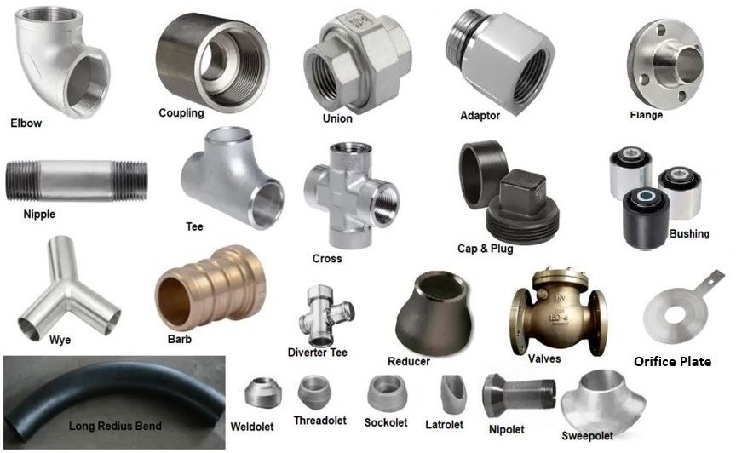
Figure 1-3: Pipe fittings

Orifice Plate

An orifice plate is a very simple device installed in a straight run of pipe. It contains a hole smaller than the pipe diameter. The flow constricts experiences a pressure drop, and then differential pressure can be related to a flow. The orifice plate is a thin plate with a hole in the middle and is usually placed in a pipe in which fluid flow. The orifice plate has three different shapes, concentric, eccentric and segmental as shown in figure 1-4. Kone et al. [29].

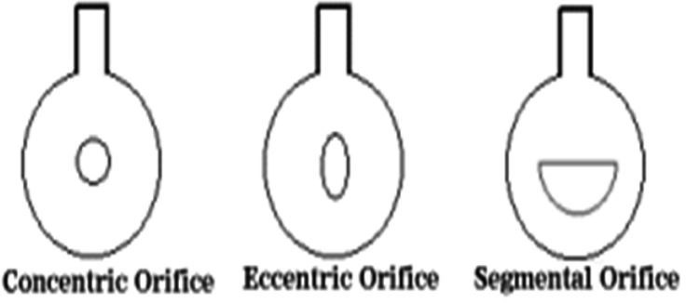

Figure 1-4: Different shapes of orifice plates

Elbow

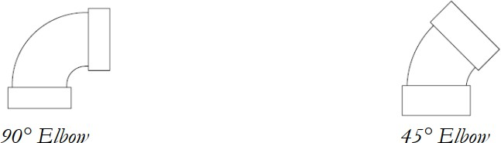
Elbows are very important pipe fitting installed between two lengths of pipe or tube mainly to allow a change of direction, usually 90° or 45°. The ends may be machined for butt welding, threaded (usually female), or socketed, etc. When the two ends differ in size, it is called a reducing or reducer elbow. elbows are available in short radius or long radius of types, short radius elbows are more common while the long radius elbows are used on applications that need to ensure smooth flow, reduce wear to both product and piping and to reduce the chance of getting blockages. Figure 1-5 shows the configuration of 90° and 45° elbows.

Figure 1-5: Elbows configuration

Tee

Another pipe fitting which is very important to either combine or split a fluid flow. Equal tees are the most common (tees which have the same body and branch diameter) but there is also a wide range of reducing tees where either the branch or the body is a different diameter relative to each other. A swept tee is where the branch enters the body at an arc and is used to minimize the frictional losses and promote flow in the system. A wye tee is where the branch is stabbed into the body at an angle and is usually used where the branch is a smaller diameter than the main pipe. Figure 1-6 shows the difference between swept tee and Wye Tee.
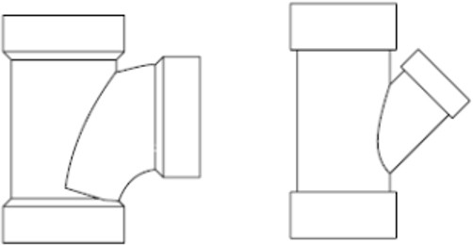

Figure 1-6: Difference between Swept Tee & Wye Tee

Reducer

Reducers are used to join two different pipe sizes together. They can be either concentric or eccentric which refers to the relative position of the center lines of the outlet and inlet. Reducers must be installed correctly when using in a horizontal position as the wrong slope will prevent free draining of a system or may cause blockage in the system. The concentric and eccentric reducers are shown in figure 1-7.
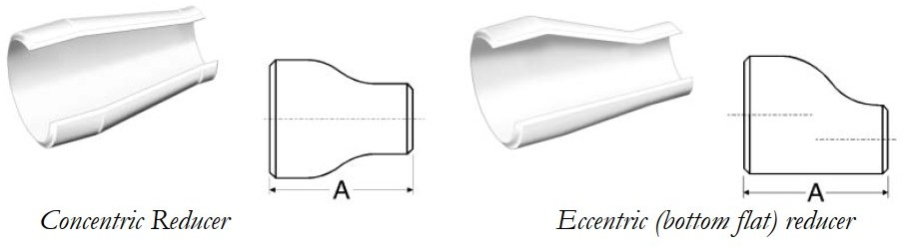

Figure 1-7: Difference between concentric and eccentric reducers

Union

When two ends of pipes are joined, the pipe fitting used is called union. A union is made of three parts namely a nut, a male end and a female end. The male and female ends are assembled with the support of the nuts, and necessary pressure is made to connect the joint. A union is similar to a coupling, the main difference that it is designed to facilitate the quick and convenient disconnection of pipes for maintenance or fixture replacement. While a coupling is usually a permanent joint or requires the ability of being able to rotate all the pipe to one side of it to unscrew it, a union provides a simple nut transition, allowing easy release at any time. Figure 1-8 shows the configuration of the union.

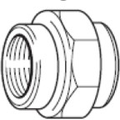
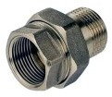

Figure 1-8: Unions

Cap or Plug

A type of pipe fittings which are used to cover the end of a pipe. A cap has a similar function to a plug. For screwed systems the cap would have female threads where a plug would have male threads. The cap and plug are shown in figure 1-9.

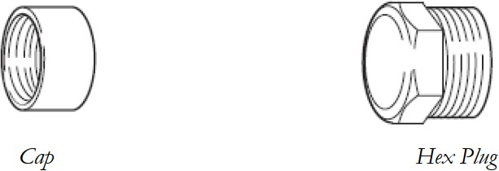

Figure 1-9: Difference between Cap & Plug

PIPE FITTINGS CONNECTION

A variety of joints are used in an assembly of pipes. Pipes are connected with the help of joints. Connecting two or more pipes together is called a fitting. Various types of joints could be used in a pipe as per the requirement. Joints are also used for multiple pipe connections, and are an important

component of the plumbing system. Generally, the pipe joint fitted can easily sustain the pressure created in the pipe.

Types of pipe joints:

Pipe joints are joined together by various types as follows.
- Threaded joint
- Welded joint
- Grooved joint
- Flanged joint
- Compression joint
- Brazed joint
- Threaded joint
- Soldered joint

VALVES TYPES

Fluids and gasses must be regulated and controlled not just flow freely through piping systems. Valves not just used to be ON/OFF state, but also to regulate pressure or flowrate depending on the design parameters. Valves may be operated manually, either by a hand wheel or a lever or operated automatically by a pneumatic actuator or electrical drive motor. There are a number of different types of valves used in piping systems, the most common types of valves:
- Ball valve
- Butterfly valve
- Globe valve
- Check valves
- Diaphragm valve
- Process control valves
- Safety Relief valves

The most common valves used will be discussed below.

Ball Valve

A ball valve is a valve with a spherical center which controls the flow through it. The sphere has a hole, or port, through the middle so that when the port is in line with both ends of the valve, flow will occur. When the valve is closed, the hole is perpendicular to the ends of the valve, and flow is blocked.

The handle or lever is also in line with the port through the sphere which allows the operator to know whether the valve is opened or closed. Ball valves do not offer the fine control that may be necessary in throttling applications; however, they are durable and usually work to achieve perfect shutoff even after years of disuse and are suitable for high pressures and temperatures. The manual ball valve is shown in figure 1-10.
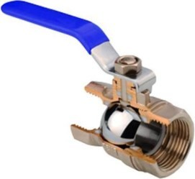
Figure 1-10: Manual Ball Valve

Butterfly Valve

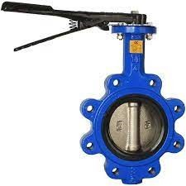
The butterfly valve like the ball valve is part of the family of quarter turn valves, i.e., they only require a quarter turn to achieve their fully open position. The butterfly valve can be used for isolating or regulating flow. The closing mechanism takes the form of a disc whose position is again indicated by the position of the opening lever. Butterfly valves are generally favored because they are lower in cost to other valve designs as well as being lighter in weight, meaning less support is required. The disc is positioned in the center of the pipe, but unlike a ball valve, the disc is always present within the flow, therefore a pressure drop is always induced in the flow, regardless of valve position. The butterfly valve is shown in figure 1-11.

Figure 1-11: Butterfly Valve

Globe Valve

A globe valve is a type of valve used for regulating flow in a pipeline, consisting of a movable disk- type element (the plug) and a stationary ring seat in a generally spherical body. While they can be used as a shut-off valve they are not generally selected for this function alone as the baffle inside the valve restricts flow even when the valve is fully open. The cross section for the globe valve is shown in figure 1-12.
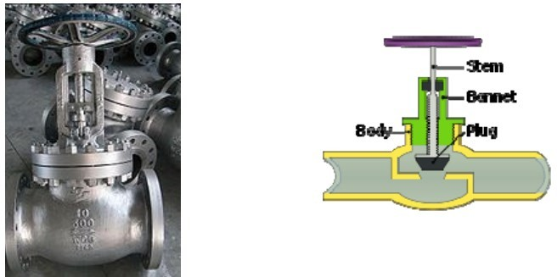

Figure 1-12: Cross- section for the Globe Valve

In a globe valve, the plug is connected to a stem which is operated by screw action in manual valves. Typically, automated valves use sliding stems. Automated globe valves have a smooth stem rather than threaded and are opened and closed by an actuator assembly. When a globe valve is manually operated, the stem is turned by a hand wheel which requires 3 to 4 complete revolutions to open or close the valve.

Check Valve

A check valve, non-return valve or one-way valve is a mechanical valve, which normally allows fluid (liquid or gas) to flow through it in only one direction. An important concept in check valves is the cracking pressure (or opening pressure) which is the minimum upstream pressure at which the valve will operate. Typically, the check valve is designed for and can therefore be specified for a specific cracking pressure. Full bodied swing check valve Check valves are often used before and after pumps to ensure that they do not run dry once they have been primed or to prevent a system from draining if a pump was to fail. Diaphragm pumps use a ball check valve as part of the internal workings of the pump to ensure flow goes only in one direction. The check valve cross section view is shown in figure 1-13.

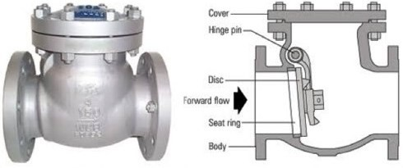

Figure 1-13: Check Valve Cross section View

Safety Relief Valve

A safety valve is a valve mechanism for the automatic release of a substance from a system when the pressure or temperature exceeds preset limits. It is a type of valve which is part of a larger family of valves known as pressure safety valves (PSV) or pressure relief valves (PRV). PSV or PRV - A valve that automatically, without the assistance of any energy other than that of the fluid concerned, discharges a certified amount of the fluid so as to prevent a predetermined safe pressure from being exceeded, and which is designed to re-close and prevent the further flow of fluid after normal pressure conditions of service have been restored. The safety valve is shown in figure 1-14.
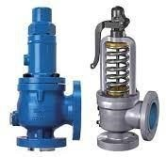

Figure 1-14: Safety Valve

PRESSURE DROP IN PIPE FITTINGS

Any piping systems are subject to a phenomenon known as pressure drop. Simply the pressure drop is the difference in total pressure between two points in a fluid carrying network. When a liquid enters one end of a piping system, and leaves the other, pressure drop, or pressure loss, will occur due to the result of resistance to flow.
There may also be a gain or loss of pressure due to the change in elevation between the start and end of the pipe. This overall pressure difference across the pipe is caused by many factors. Such as friction between the fluid and the wall of the pipe, friction between adjacent layers of the fluid itself, friction loss as the fluid passes through any pipe fittings, bends, valves, or components.

Concept of Pressure Drop

The pressure drop will occur while the frictional force caused by the resistance to flow acting on the fluid as it flows through the pipe. The main factors that affect the resistance to the liquid flow are fluid velocity through the pipe and the fluid viscosity. Pressure drop is in sometimes proportional to the frictional shear forces within the pipe network.

Fluid will experience a pressure drop when it passes through fittings or instruments caused by the frictional resistance of the parts exposed to the fluid. Each instrument and fitting cause some certain amount of drop in pressure.

Factors affecting pressure drop

      - The Fluid Characteristics

Understanding the nature of the fluid being pumped through specified system is very important when considering the pressure drop in this system, The most important fluid properties affecting the pressure drop are:
- Density
- Heat capacity
- Temperature
- Viscosity

For example, in a food processing plant, some products change their viscosity dramatically when being pumped through a pipeline due to shear. These types of products will become thinner due to friction caused by the passage through the pumps and the interior surfaces of the pipes. In contrast, other products, don’t experience any changes in viscosity when subjected to shear force. Newtonian fluids are liquids which are not thixotropic, and are not subject to changes in viscosity when subjected to shear force. Products which exhibit Newtonian characteristics, therefore, can contribute to higher pressure drop when being pumped through a pipeline because their viscosity does not significantly change as it passes through the system.

Pressure Drop Calculations

For a specific piping system, the overall pressure drop may be calculated by applying several

P(end) = P(start) - friction loss- fittings loss + elevation (start-end) + pump head (1-2)

equations. Simply, the pressure drop in the piping system is given by equation (1-2):

Where;
P(end)= pressure at the end of the pipe. P(start)= pressure at the start of the pipe.
Delta Elevation = (elevation at the start of the pipe) – (elevation at the end of the pipe) Pump head= 0 (if no pump is present).

So, when designing a process system to minimize or eliminate pressure drop, process plant engineers should do the following:
- Minimize the number of additional mechanical components (valves, flow meters, adaptors, and couplings) in a process pipeline, as all of these can add to problems with pressure drop.
- Ensure that the process pipeline is laid out to be as compact as possible, minimizing pipe lengths and bends. Excessive pipe run lengths and changes in direction will contribute to pressure drop.
- Make sure that the process pipelines are as level as possible, ideally with both staring and end elevations close to the same height. As noted above, changes in piping elevation in the overall system will contribute to either pressure drop or overpressure situations.
- Ensure that the process pipe’s interior diameter and the size of the pump (horsepower, throughput) are properly sized for the type of fluid that’s being piped through the system. Mistakes made in either of these can result in either excessive pressure drops or overpressure situations.

Darcy-Welsbach equations

The most common methods used to determine the friction head loss in pipe are based on Darcy- Welsbach equations. The level of accuracy of this method depends on the type of flow being pumped. The frictional loss formula is given by the following equation (1-3):

H = f L V^2
2 g D
(1-3)

Where;

H = pressure drop f = friction factor
L = length of the tube
v = velocity of the fluid
g = acceleration due to gravity D = inner diameter of the tube

For Laminar flow, Re less than 2200 the friction factor is given by the following equation (1-4):

f = 64
Re
(1-4)

The Colebrook equation expresses the Darcy friction factor f as a function of Reynolds number Re and pipe relative roughness ε / Dh, fitting the data of experimental studies of turbulent flow in smooth and rough pipes. The equation can be used to (iteratively) solve for the Darcy–Welsbach friction factor f.

For a conduit flowing completely full of fluid at Reynolds numbers greater than 4000, it is expressed as the following in equation (1-5):
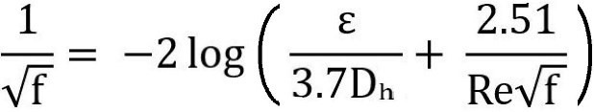 (1-5)

Where;
Dh = Hydraulic Diameter (m).

Pressure drops in Pipe Fittings

Head Loss or pressure drop in Pipe fitting is usually defined as the equivalent length of pipe that is added to the straight run of pipe. The pressure drop due to increase or decrease in pipe diameter here are some reasons for the fitting pressure drop:
- Gradual enlargements
- Gradual contractions
- Sudden enlargements
- Sudden contractions
- Rounded entrances
- Long pipe bends

Sometimes the pressure loss of a fitting is expressed as an 'Equivalent length' of pipe, where by the engineer calculates a further length of pipe that will produce an extra friction loss in the pipe that is equivalent to the loss through the fitting. In this way, adding a notional extra length to each pipe can model the further pressure loss that would have occurred due to the fittings.

for each type of fittings. In this approach K-factor is multiplied by the velocity head of the fluid flow by the following equation (1-6):

H = K (V² /2 g) (1-6)

Where;
H = Head loss, m
V = Velocity of flow, m/s

K factors for many different types of valves and fittings are given in the following figure 1.15:
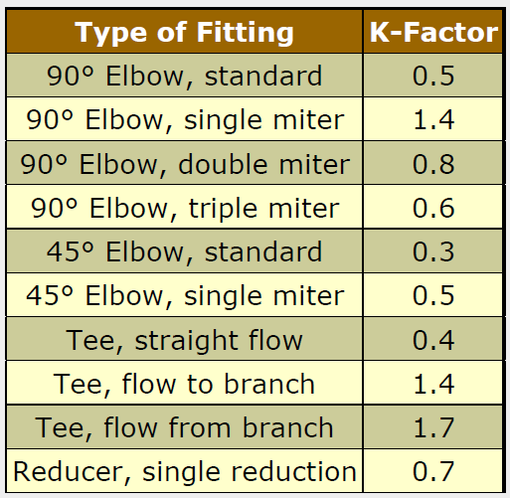

Figure 1-15: K factors for misc. pipe fittings

PUMPING POWER

The pump is one of critical components of the piping system, it controls the quantity of the flow passing through the system. Pumps are used to overcome the head loss due to elevation and friction loss within the pipe, particularly for pumping over horizontal distances, can be calculated using the Darcy-Weisbach equation (as discussed before). Pump proper sizing and selection is essential to prevent either flow stoppage or high-speed flow.

Pumping energy is the most important part to be considered when designing a piping system, it is calculated as the volume of the fluid per unit time (flow capacity) times the density of the fluid times the gravitational constant times the pumping head (vertical distance to be pumped). Pumping energy is simply power multiplied across time.

The head loss due to friction, and as such the required pumping power, is proportional to the square of the fluid speed. As such, this is an important calculation because if your system is designed in a way that requires high pumping speeds, you will have very high pumping energy costs. Additionally, if you pump too slow, you risk of fluid stoppage.

The pumping power can be calculated simply using this equation (1-7) to determine the power needed for the pump and the running cost.

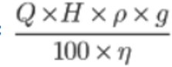
Pumping Power (watt) = (1-7)

Where;
Q = Flow rate in m³/s
H = Total developed head in meters = Density in kg/m³
g = Gravitational constant = 9.81 m/s²
η = Efficiency of the pump ( between 0% to 100%)

Chapter Two

2 LITERATURE REVIEW

INTRODUCTION

This work points out the previous studies and recent progress in the utilization of nanofluid and the improvement in the thermophysical properties of the nanofluid in addition to latest researches in the utilization of the nanofluid in orifice plates. Thermophysical, heat transfer characteristics of nanofluid and different factors such as particle size, shape, surfactant, temperature, etc. on thermal conductivity are presented. The studies emphasize the widespread of the nanofluid applications such as in heat exchanger, transportation cooling, refrigeration, electronic equipment cooling, transformer oil, industrial cooling, nuclear system, machining operation, solar energy and desalination, etc. Few barriers and challenges were also addressed Ali et al. [30].
In the last decade, as energy costs have escalated rapidly, there is a tremendous need for new kinds of heating/cooling fluid which will increase the thermal efficiency of the system and thus reduce overall energy consumption. Nanofluids have attracted attention as a new generation of coolant for various industrial and automotive applications because of their excellent thermal performance. Nanofluids are the dispersions of nanometer-sized particles (<100 nm) in a base fluid such as water, ethylene glycol or propylene glycol. Use of high thermal conductivity metallic nanoparticles (e.g., copper, aluminum, silver, silicon) has the effect of increasing the thermal conductivity of such mixtures, thus enhancing their overall energy transport capability Kulkarni et al. [31].
Thermal conductivities of traditional heat transfer fluids, such as engine coolants and water, are very low. With increasing global competition, industries have a strong need to develop energy efficient heat transfer fluids with significantly higher thermal conductivities than the available fluids. Nanofluids offer us novel and truly innovative solutions for heat transfer fluids containing suspended nanoparticles, have been developed to meet such cooling challenges Wang et al. [32].
New generation of heat transfer mediums have been introduced to replace these conventional fluids as a result of the low thermal conductivity of the traditional conventional fluids. Heat transfer mediums with low thermal conductivity are always avoided in order to attain higher thermal efficiency of thermal devices. The addition of nanoparticles in traditional fluids renders

substantial improvement in thermal conductivity providing remarkable augmentation in thermal performance Alhajaj et al. [33].
When the fluid is flowing through the pipe, some head is lost to overcome the hydraulic resistance due to friction of the fluid with the inner surface of the pipe wall, viscosity of fluid and turbulence of the fluid flow. There are two types of head loss during fluid flow, major Head Loss and minor head Loss. Major head loss is due to friction during the fluid flow while minor head loss is due to disturbance in fluid flow pattern during the flow of fluid through sudden enlargement, sudden concentration, bend, elbow etc. Perumal et al. [34].

NANOFLUID

A nanofluid is a mixture of nano sized particles and a base fluid. Typical nanoparticles are made of metals, oxides or carbides, while base fluids may be water, ethylene glycol or oil. Generally, nanofluids are used to enhance heat transfer rate. The heat transfer enhancement using nanofluid mainly depends on type of nanoparticles, size of nanoparticles and their concentration in base fluid Chavda et al. [35].
One of the commonly used ways of thermal performance enhancement is the use of nanofluids in heat pipes. Investigators conducted a lot of experimental and numerical studies in different application areas and observed a significant augmentation in heat transfer rate with the supplementation of nanoparticles in base fluid. Different researchers worked upon this concept and experienced augmentation in heat transfer. Investigators performed experimentation by using variable concentrations, types, sizes and filling ratios of nanofluids in heat pipes and get admirable results. Some of the commonly used fillings are copper (Cu), copper oxide (CuO), silver (Ag), aluminum (Al), aluminum oxide (Al2O3), graphene and silicon carbide (SiC)-based Khalid et al. [36].
Do et al. [37] explained the mechanism of thermal performance enhancement in mesh wicked heat pipes using nanofluids. Investigators used 1.0 vol% and 3.0 vol% water based Al2O3 nanofluid and compared its performance with heat pipes filled with distilled water. Using 3.0 vol% Al2O3 nanofluid resulted in 40% reduction in thermal resistance in evaporator–adiabatic section compared to (deionized) DI water-based heat pipes.
Kim et al. [38] studied the effect of different inclination angles on thermal performance of heat pipes. Investigators used silver nanofluids in screen mesh heat pipes with particle mass concentration of 0.25, 0.5 and 0.75% and performed experimentation at 0°, 30°, 60° and 90° inclination angles. Moreover, wider range of concentrations, 0–2% was studied to explore increase in thermal conductivity and viscosity of nanofluid. It was observed that thermal

conductivity of nanofluid increased up to 6.6%, 8% and 9% for mass concentration of 0.25%, 0.5% and 0.75%, respectively. For all three cases, viscosity of nanofluid increased by 3% compared to base fluid. Maximum heat transfer has taken place at 60° inclination angle showing dependence of thermal performance of heat pipes on inclination angle as well.

NANOFLUID PREPARATION

The production of nanoparticles from various materials has become possible by the advancement of science. One of the materials characteristics in Nano-dimensions is the ratio of surface to volume, which has given them special capabilities. Nanofluids have emerged as a new exciting category of nanotechnology based on heat transfer fluids and have grown increasingly over the past few years. Scientists and engineer’s attempts to discover the laws governing the thermos-physical properties of these fluids, so they are proposing new mechanisms and offering unusual models to explain these behaviors Devendiran et al. [39].
Physical mixing and chemical reduction are two widely used preparation methods of nanofluids, the colloidal suspension of nanoparticles in base-fluid significantly improves thermophysical properties of base-fluid such as density, dynamic viscosity, specific heat capacity, and thermal conductivity Ali et al. [40].

THE IMPACT of NANOFLUIDS on FRICTION FACTORS in PIPES and PIPE FITTINGS
In industries, many heat transfer equipment are connected in serial and/or parallel to transfer the heat as per requirements of the process/product along with furnaces, columns etc. They all are connected through pipes and pipe fittings. When nanofluid is used to enhance the heat transfer properties, it also has to flow through such pipe and pipe fittings. Thus, it becomes essential to evaluate the effect of nanofluid in pipe and pipe fittings separately rather than considering along with heat transfer characteristics for a particular application Chavda et al. [35].
Due to utilization of nanofluid, resistance to flow of fluid increases which increases the friction factor and reduces the flow rate. In an experimental investigation to determine the effect of various concentration of Al2O3 nano-dispersion mixed in water as base fluid. The volume concentrations of Al2O3 nanofluid prepared are 0.001 %, 0.002 %, 0.003 % and 0.004 %. The conclusion derived for the study is that friction factor and loss coefficient of different pipes and pipe fittings increase with increase in volume concentration of Al2O3 nano-dispersion compared to water. The nanofluid exhibits different thermo-physical properties than the base

fluid. Generally thermal conductivity of nanofluids is higher than the base fluid which increases the heat transfer rate. The heat transfer enhancement using nanofluid mainly depends on type of nanoparticles, size of nanoparticles and concentration of nanoparticles in base fluid Perumal et al. [34].
Many researchers have studied numerically and experimentally the phenomenon of effect of nanofluid on friction factor. The studies reported in literatures have been referred to and presented here. Numerically three-dimensional turbulent flow and heat transfer of two different nanofluids for nanoparticles volumetric concentrations up to 6%, containing aluminum oxide (Al2O3) and copper oxide (CuO) nanoparticles, dispersed in ethylene glycol and water mixture (EG/W) in the flat tubes of an automotive radiator have been studied to evaluate their performance. For the same Reynolds number, nanofluids show an increase of friction factor and heat transfer coefficient with an increase in the particle volume concentration Vajjha et al. [41]
Experimental investigations on TiO2 and SiO2 water-based nanofluids (with average particle sizes of 50 nm and 22 nm) were conducted. The study examined heat transfer coefficient and friction factor. Nanofluids were tested in a circular tube under turbulent flow with constant heat flux boundary conditions. Results indicated that pressure drop is directly proportional to nanoparticle density. Azmi et al. [42]
Heat transfer coefficient and friction factor of TiO2 nanofluid of volume concentration range from 0.0004% to 0.02% in base fluid of 40% of ethylene glycol and 60% of distilled water flowing in a double pipe heat exchanger with and without helical coil inserts have been studied experimentally. It has been reported that the heat transfer coefficient and friction factor get enhanced compared to base fluid flowing in a tube Reddy et al. [43]
An experimental study examined the heat transfer and flow characteristics of Al2O3/water nanofluid in a circular tube. Nanofluids were prepared using a two-step synthesis method with concentrations of 0.01, 0.05, 0.1, and 0.3 wt.%. A test rig measured heat transfer coefficient and pressure drop under laminar flow and constant heat flux conditions. Results demonstrated an increasing trend in heat transfer coefficient and Nusselt number for nanofluids. The maximum enhancements were observed at a flow rate of 0.5 L/min compared to 0.15 L/min, with a 28.06% increase in heat transfer coefficient and a 29.93% increase in Nusselt number at
0.3 wt.%. Despite a penalty in pressure drop, the use of Al2O3/water nanofluids remains advantageous for heat transfer applications. Arora et al. [44].
In an experiment using SiO2/ Water nanofluid instead of water in shell and helically coiled tube heat exchanger, the friction factor and pressure drop for SiO2/water nanofluids were noticed to

be increased by remarkable percentage compared to water. Efforts are taken to improve the heat transfer efficiency so in this experiment. Niwalkar et al. [45].
In addition, the convective heat transfer and flow behavior of nanofluids flowing upward through a vertical pipe. Results indicated that the convective heat transfer coefficient increases with nanoparticle concentration, and the pressure drop of the nanofluid flows is very close to that of the base fluid flow for a given Reynolds number. He, et al. [46].

PUMPING POWER IN NANOFLUIDS

Most fluids containing solid nanoparticles have been shown to possess enhanced thermal conductivities compared to their base fluids, and therefore there exists the possibility to have increased heat transfer coefficients but the addition of nanoparticles to a fluid also increases its viscosity, this increased viscosity will result in an increase in the power required to pump the nanofluid at the same velocity as the base fluid as has been reported for 5 vol% of Al2O3, CuO, and diamond nanoparticles in water. However, if the heat transfer of a nanofluid is much higher than that of the base fluid, the nanofluid could be pumped at a lower velocity than that of the base fluid while maintaining the same heat transfer rate. The magnitudes of both the heat transfer coefficient and the pumping power for a particular application are required to determine the viability of a nanofluid. Routbort, et al. [47].
Nanofluids consisting of nanometer-sized alumina particles suspended in water have been used in many experiments to study general characteristics of nanofluids. The alumina particles used in a study have a fairly uniform size, stay in suspension well, and make a good nanofluid for comparing experimental results to calculations. There have been several nanofluid studies in which the pressure drops, from which the pumping power can be calculated, was measured in straight tubes. Pressure drop was measured using 5 vol% concentrations of three nanofluids including alumina in water under turbulent flow conditions Torii et al. [48].

PIPES AND FITTINGS FRICTION LOSSES

Dealing with pipes and pipe fittings involves understanding how these fittings impact the flow of fluids. They are widely used in industries such as oil & gas, chemical, pharmaceutical, and food processing. Choosing the right size and type of fitting, considering the pipe roughness, and ensuring suitable flow rate (Q) are crucial for design and operation. Insufficient pumping or high friction losses can hinder fluid delivery. Friction and head losses in pipes, bends, and valves pose challenges in fluid transportation. The quantity of fluid, pump capacity, and fluid

properties determine the flow resistance and affect the efficiency of fluid transport in process industry pipelines. Ntengwe et al. [49]
The orifice plates are most commonly used for continuous measurement of fluid flow in pipes. The orifice plate creates a pressure drop. Based on the magnitude of pressure drop, flow rate can be calculated. Mohamed et al. [50]
Studies elsewhere have shown that high velocities produce high resistances to flow in pipes and hence high HL values for specific type of surface roughness. Darcy- Weisbach, Hazen- Williams, Moody and Fanning showed that for any flow of fluid in a pipe exhibiting some form of roughness; head losses (HL) due to friction were produced Coulson et al. [51].
The design of piping and pumping systems needs a knowledge of the pressure drop due to flow in straight pipe segments and through valves and fittings. Friction losses caused by the presence of valves and fittings usually results from disturbances of the flow, which is forced to change direction abruptly to overcome path obstacles and to adapt itself to sudden or gradual changes in the cross section or shape of the duct Polizelli et al. [52]. Evaluation of the friction loss in valves and fittings involves determination of the appropriate loss or resistance coefficient, k, which is calculated from experimental measurement or numerical calculation of the pressure drop in the fitting. Engineers and technicians involved in the project of piping systems often find it difficult to obtain the necessary resistance coefficient values, since the amount of available data in the literature is quite limited.
Experimental data on resistance coefficients have been collected using carbon steel valves and fittings. However, in the food, the pharmaceutical and some chemical industries, fluids should be handled by means of sanitary piping components, which are made of stainless steel and often have distinct design patterns in order to assure hygienic cleanliness and bacteriological safety. Considering the lack of published data and the practical importance of their knowledge, researches conducted an experiment to obtain loss coefficients for the laminar and turbulent flows of power-law fluids through stainless steel, sanitary valves and fittings Martínez et al. [53].
Telis-Romero conducted an experiment to study the performance of a pipeline system by taking the pressure drop measurements, experimental data obtained during flow of ethylene glycol were used to evaluate the friction factor. Telis et al. [54].

APPLICATIONS OF NANOFLUIDS

There are many potential applications of nanofluid, researchers have applied nanofluid in different fields such as heat exchanger, industrial cooling, automotive cooling system, nuclear systems, solar absorption, etc. More researches should be carried out before the application of nanofluid in nuclear system and some other fields Ali et al. [30].
Recent technological advancements have intensified heat generation in various industrial sectors such as heating, ventilation and air-conditioning (HVAC), thermal power plants, transportation, microelectronics, aerospace, and manufacturing Sheremet et al. [55].
Rapid development is taking place in warfare and armament electronic design and application. This phenomenon has led to dramatic increases in chip densities and power densities, as well as continuous decreases in the physical dimensions of electronic packages. Hence, thermal management continues to be one of the most critical areas in electronic product development. Advances in thermal management will significantly impact the cost, overall design, reliability and performance of the next generation of weapons technology that heavily uses microelectronic devices Kulkarni D. P., 2007 [31].
Numerically investigation the possible application of nanofluids as a jacket water coolant in a gas spark ignition engine. They performed numerical simulations of unsteady heat transfer through the cylinder and inside the coolant flow. They have shown that because of higher thermal diffusivity of nanofluids, the thermal signal variations for knock detection increased by 15% over that predicted using water alone Ollivier et al. [56].
The thermally driven absorption system is an alternative to the vapor compression system, which may lead to environmental problems such as global warming and ozone layer depletion due to the use of certain refrigerants. The absorber is the most critical component in the absorption system. In order to improve the performance of the absorber, several studies have been carried out. Kim et al. [57] showed that by adding nanoparticles such as Cu, CuO and Al2O3 to a NH3/H2O solution improved the absorption performance by 5.32 times.

Chapter Three

3 CFD SIMULATION OF NANOFLUIDS

INTRODUCTION

A nanofluid comprises nano-sized particles dispersed in a base fluid, often consisting of metals, oxides, or carbides as nanoparticles, and water, ethylene glycol, or oil as the base fluid. These nanofluids exhibit distinct thermophysical properties, including enhanced heat transfer rates due to their higher thermal conductivity compared to the base fluid. The extent of this enhancement depends on various factors, such as the type, size, and concentration of the nanoparticles in the base fluid.

When fluid flows through a pipe, head loss occurs due to hydraulic resistance resulting from friction with the pipe wall, fluid viscosity, and turbulence. Friction during fluid flow is responsible for major head loss, while minor head loss originates from disruptions caused by sudden changes in pipe geometry, bends, elbows, and other factors.

To validate the numerical data and check the accuracy and reliability of the solver, a comparison was made with a published paper by Tukiman et al. [59]. They employed commercial Computational Fluid Dynamics (CFD) software to predict the flow characteristics in an orifice plate.

The study focuses on two-dimensional turbulent flow of nanofluids with a 4% volumetric concentration of aluminum oxide (Al2O3) dispersed in water. It aims to examine the friction factor and loss coefficient of Al2O3 nanofluid through an orifice at different flow rates and compare the results with those of water.

GOVERNING EQUATIONS AND MODELLING ASSUMPTIONS

To solve the flow in an orifice plate, the governing equations of continuity and momentum, along with the appropriate Reynolds stress closure, must be solved. In this study, the standard k-epsilon turbulence model has been employed, considering the flow to be steady-state and incompressible. The governing equation for the flow in the orifice plate is presented below:

Conservation of mass;

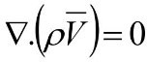
(3.1)

y-momentum;
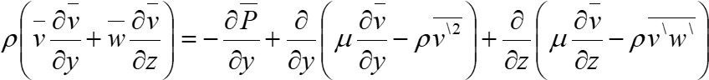

z-momentum;
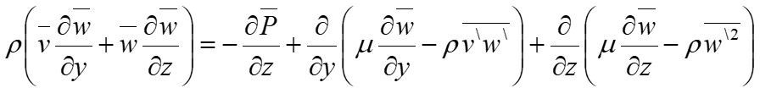

GEOMETRY, GRID AND COMPUTATIONAL DOMAIN
    - Model Geometry

(3.2)

(3.3)

CFD simulations were conducted to analyze the flow characteristics of water and aluminum oxide Al2O3 nanofluid through an orifice plate. The geometry is modeled with the same dimensions mentioned in Tukiman et al. [59], with the orifice plate having a throat diameter (d) of 5 mm. and a length (t) of 2 mm. The upstream flow length (Lupstream) is 246 mm, while the total length of the pipe (Ltotal) is 494 mm. The inlet diameter (D) of the pipe is 12.30 mm, as shown in Figure 3.1.
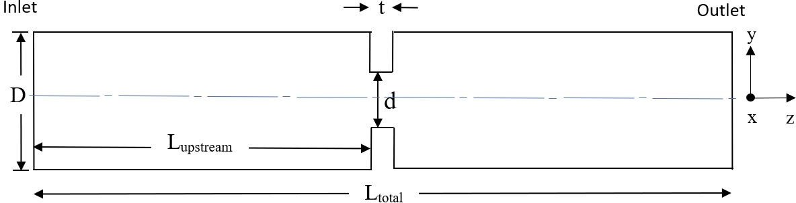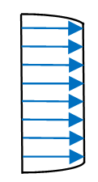

Figure 3-1: The Orifice Geometry

Boundary Conditions

To solve the governing equations, specific boundary conditions were defined for the computational domain, and from the inlet boundary all variables are initiated:
- At the inlet boundary, a "velocity inlet" condition was applied, assuming a parabola profile flow with a max velocity of 0.38 m/s, and the parabolic velocity profile is calculated using the equation:

U = U_{max} * [1-$\frac{y}{R}$]^{1/7} (3.4)
R : radius of pipe

- The Static pressure was assigned to the outlet pipe in order to determine relative pressure drop between inlet and outlet.

Thermo-physical Properties of the Fluids

The working fluids considered in this simulation include water and an aqueous Alumina (Al2O3-H2O) nanofluid with a volume concentration (𝜑) of 4%. The thermophysical properties of water and Al2O3 nanoparticles were adopted from other study Avinash et al. [58] and are presented in Table 3-1.

Table 3-1: Thermo-physical properties of Al2O3 nanoparticles

Materials | Density, 𝛒  (kg/m3) | Specific heat, CP (J/Kg K) | Thermal conductivity, K  (W/m K) | Viscosity, 𝛍  (kg/m s)
Al2O3 | 3600 | 765 | 36 | 0.000441295

- Thermo-physical properties of nanofluid
The following equations (3.5) and (3.6) which are used to determine the thermo-physical properties like density and viscosity of the nanofluid respectively.

Density:
𝜌𝑛𝑓 = 𝜑 𝜌𝑝+ (1-𝜑) 𝜌𝑏𝑓 (3.5)
where 𝜌𝑛𝑓 is the density of nanofluid, 𝜑 is the volume concentration, 𝜌𝑏𝑓 is the density of base fluid, 𝜌𝑝 is the density of nanoparticles.

Viscosity:
𝜇𝑛𝑓 = 𝜇𝑏𝑓 (123𝜑² + 7.3𝜑 + 1) (3.6)
From the above equations thermal physical properties of Al2O3 nanofluid has been calculated for volumetric concentration 4% as shown in Table 3-2.

Table 3-2: Thermophysical properties of water and of Al2O3

Materials | Density, 𝛒  (kg/m3) | Viscosity, 𝛍  (kg/m s)
Water (H2O) | 998.2 | 0.001003
Al2O3 nanofluid | 1086 | 0.000657

NUMERICAL PROCEDURE USING CFD

In this study, the two-dimensional forced convection flow was modeled using the commercial CFD solver, ANSYS FLUENT 19 R3. The discretization was performed using a second-order upwind interpolation scheme, and the velocity and pressure fields were coupled using the Semi-Implicit Method for Pressure-Linked Equations (SIMPLE) algorithm. The pipe was considered as a solid wall with a no-slip condition. The k-epsilon model was selected as the turbulence model. The simulation was terminated when the residuals of pressure and velocities reached a value below 0.00001.

Mesh Independence Study

To ensure the independence of the solution on grid size and the number of generated cells, a grid independence study was conducted. Eleven different Quadrilateral meshes, labeled as M1 to M11, were generated with various grid sizes starting from 325,384 to 15,865 cells. Figure 3-2 presents the mesh structures with the highest and lowest number of mesh elements, respectively.


(a)

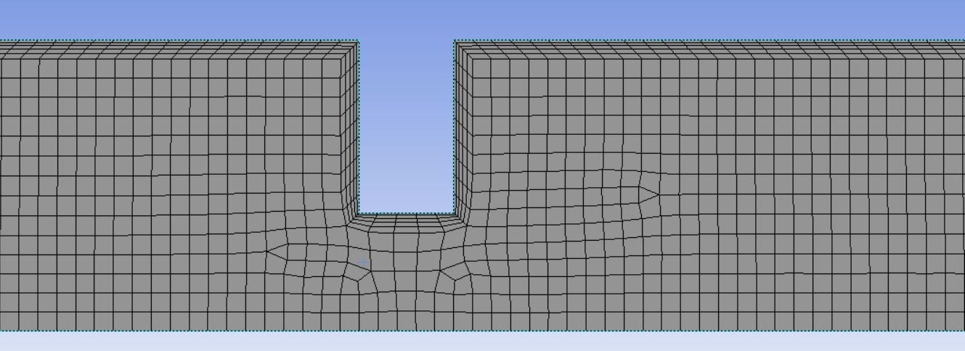
(b)

Figure 3-2: 2D Mesh Size of the computational domain with no. of mesh elements (a) 325,384 and (b) 15,865

The results of the analyses in terms of loss coefficient changing with number of mesh elements was given in Figure 3-3. It is clear from the figure that the loss coefficient values remain constant from M1 to M5, after which they start to change.
It was found that mesh M5, with a total of 148,092 elements, provided a reasonable combination of accuracy and computational efficiency shown in figure 3-4.

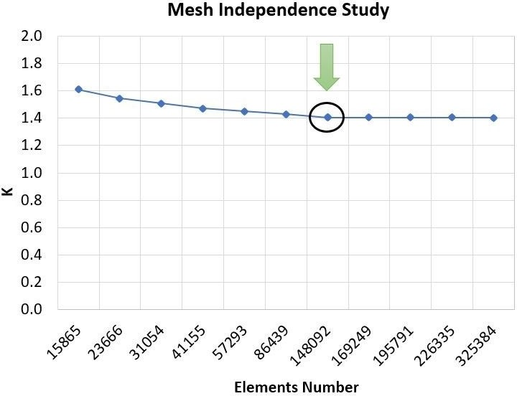

Figure 3-3: Loss coefficient changing with number of mesh elements


Figure 3-4: 2D Mesh Size of the computational domain M5 with no. of mesh elements 148,092

Validation of Numerical Results

To validate the numerical data and check the accuracy and reliability of the solver, a comparison was made with a published work by Tukiman et al. [59] They employed commercial Computational Fluid Dynamics (CFD) software to predict the flow characteristics in an orifice plate. The outcomes of their CFD simulations, including velocity and pressure profiles, are discussed in detail. The findings indicated the presence of jet-like flow in the core region, as well as recirculation, and shear layer regions.
In order to verify the accuracy of my results obtained using Ansys R3 2019, a comprehensive comparison was conducted with Tukiman et al. [59]. Specifically, the pressure drop (Figure 3-5), velocity vectors (Figure 3-6), velocity contour (Figure 3-7), and centerline axial velocity (Figure 3-8) were compared and analyzed. This verification process plays a crucial role in ensuring the validity of my simulation outcomes. By aligning the results with those of the Tukiman et al. [59].

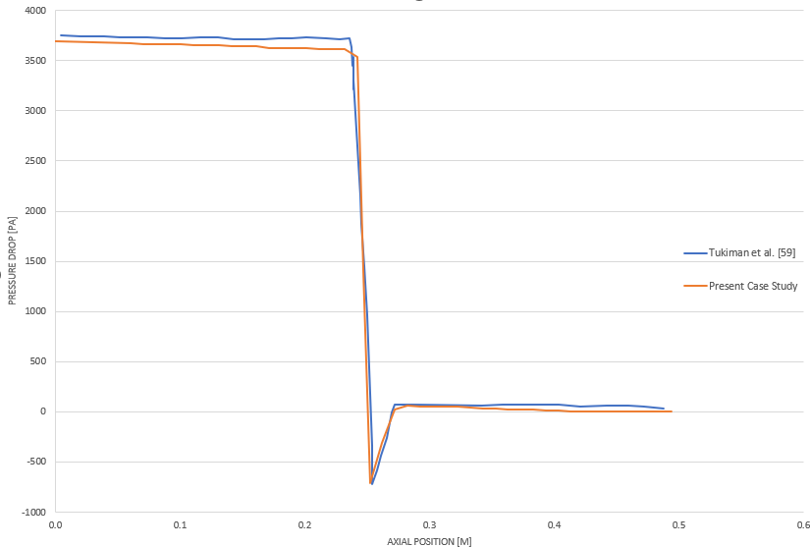

Figure 3-5: Pressure Drop Profile Tukiman et al. [59] and Present Case Study

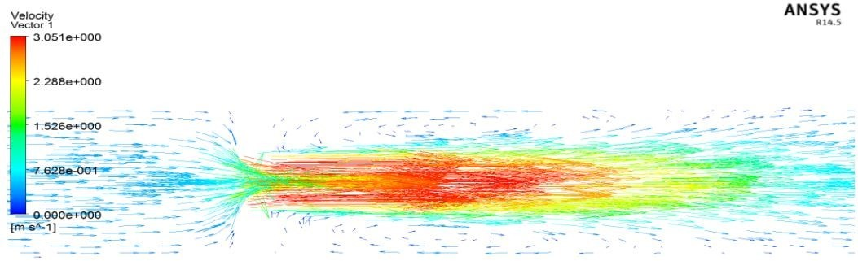
(a)

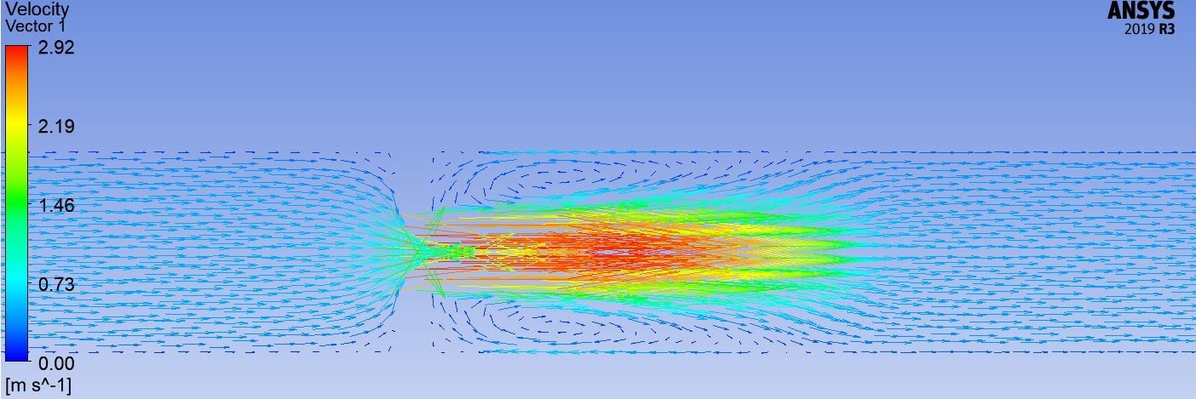
(b)

Figure 3-6: Velocity Vectors Profile (a) Tukiman et al. [59] and (b) Present Case Study

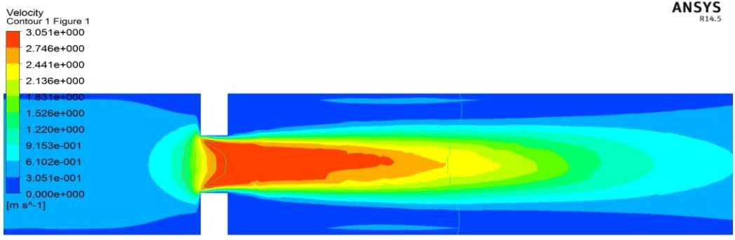
(a)

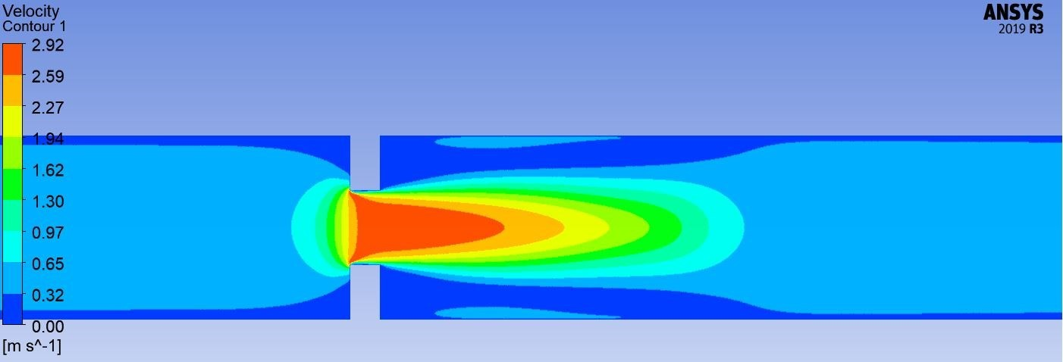
(b)

Figure 3-7: Velocity Contour Profile (a) Tukiman et al. [59] and (b) Present Case Study

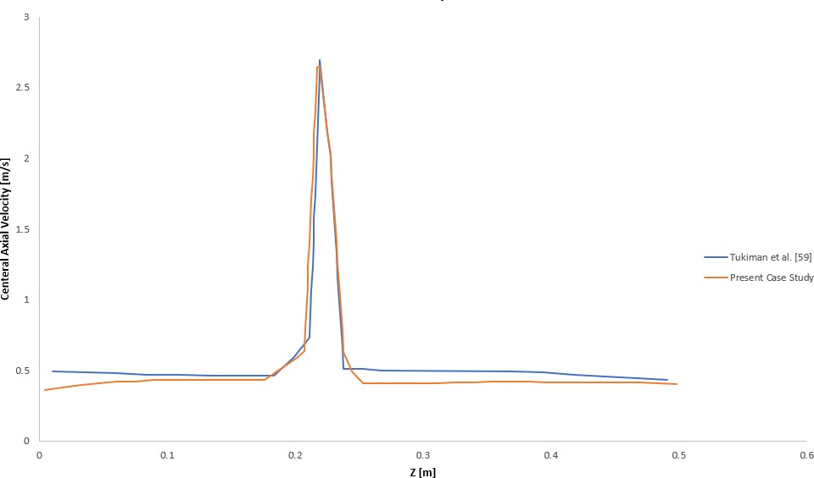

Figure 3-8: Centerline Axial Velocity Tukiman et al. [59] and Present Case Study

RESULTS AND DISCUSSION
    - Pressure Drop

As shown in Figure 3-9, the pressure drop variation with flow rate is illustrated. The utilization of aluminum oxide Al2O3 nanofluid instead of water results in an increase in pressure drop ranging from approximately 9% to 11% for flow rates ranging from 10 ℓ/min to 50 ℓ/min. This increase can be attributed to the higher physical thermal properties of the nanofluid, particularly its viscosity, which leads to an increase in pressure drop. The higher velocity and viscosity of the nanofluid contribute to the observed increase in pressure drop.
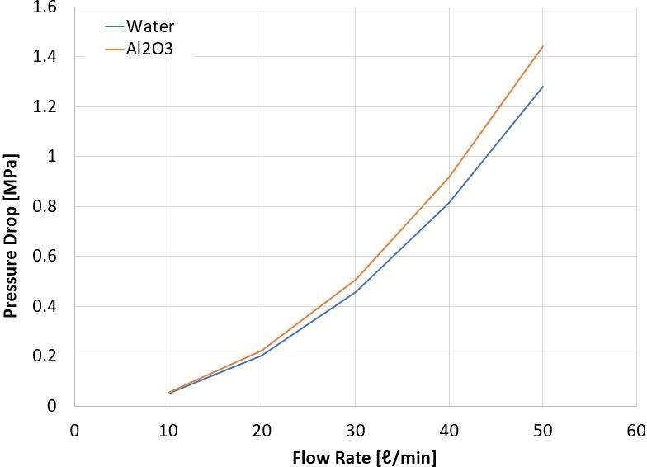

Figure 3-9: Variation of Pressure drops with Flow rate for Al2O3 Nanofluid and Water

Loss Coefficient

Figure 3-10 shows the variation of the loss coefficient with flow rate for the selected nanofluids and water. The loss coefficient remains constant across all flow rate values, indicating that the choice of nanofluids or water does not significantly affect the loss coefficient.

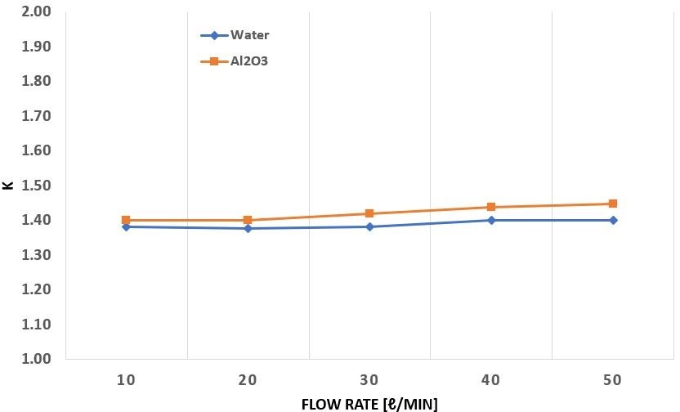

Figure 3-10: Loss coefficient variations with Flow rate for water and Al2O3 nanofluid

Pumping Power

To compensate for the pressure loss, the system requires additional pumping power. The pumping power expressed in Eq. (3.4).
𝑃𝑃 = Δ𝑃 Q (3.7)

Figure 3-11 presents the effect of using aluminum oxide Al2O3 nanofluids in comparison to water on the pumping power as a function of flow rate. It is observed that the pumping power increases with an increase in the flow rate. Deionized water exhibits lower pumping power compared to the nanofluid. The utilization of aluminum oxide Al2O3 nanofluid instead of water leads to an increase in pumping power ranging from approximately 9% to 11% for flow rates of 10 ℓ/min to 50 ℓ/min, respectively.
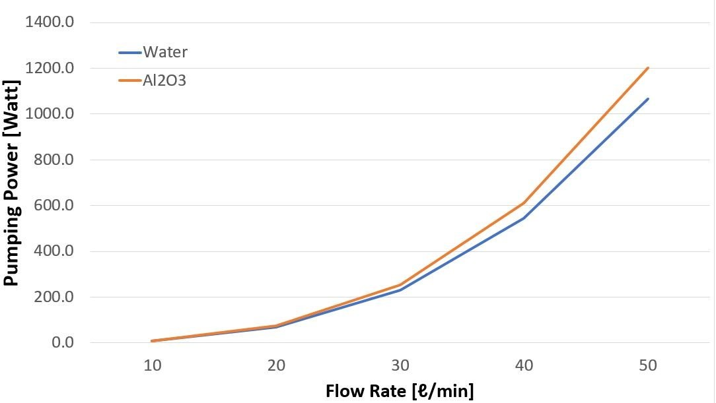
Figure 3-11: Variation of Pressure drops with Flow rate for Al2O3 Nanofluid and Water

Chapter Four

4 CONCLUSION AND FUTURE WORK

CONCLUSION

The fluid flow characteristics through an orifice plate were analyzed numerically, considering both water and Al2O3 nanofluid. The obtained water results were verified to published data and showed good agreement in terms of flow pattern, velocity profiles, and pressure profile.
The influence of the nanofluid on fluid flow through the orifice in a pipeline was evaluated, demonstrating its impact on the pressure drop and pumping power. It is concluded that utilizing Al2O3 nanofluid instead of water leads to an increase in pressure drop and pumping power ranging from approximately 9% to 11% for flow rates between 10 ℓ/min to 50 ℓ/min. This increase can be attributed to the higher physical properties of the nanofluid, particularly its viscosity, which leads to an increase in pressure drop. The higher velocity and viscosity of the nanofluid contribute to the observed increase in pressure drop.

FUTURE WORK

The present study presents recent developments of nanofluid in heat transfer enhancement. The study extends to the preparation of nanofluid, stability of nanofluid, enhancing the stability of nanofluid, thermophysical properties, heat transfer characteristics. Nanofluid has some challenges for which further research should be conducted. Some probable studies that can be carried out in future research are listed below:
    - Preparation of nanofluid is costly. Hence, efforts are required to identify cost-effective techniques for the nanofluid preparation.
    - Stability is the main challenge of nanofluid which is crucial in the application as heat transfer fluid. More researches are required though some techniques are adopted in enhancing stability of nanofluid. The optimum time of sonication and magnetic stirring is not determined yet for different types of nanofluid. Moreover, optimum concentration of surfactant is not determined yet.
    - The combination of different nanoparticles is not yet touched. Hence, effort can be made to find out the thermophysical properties of hybrid nanofluid.
    - Multi-Walled Carbon Nanotube (MWCNT) demonstrates high thermal conductivity but very few studies have been carried out regarding the thermophysical properties and heat transfer characteristics of MWCNT. Research can be carried out for MWCNT nanofluid.

    - Correlations for the thermophysical properties and heat transfer characteristics of different nanofluid are not yet been formulated. Researchers can carry out investigation in order to formulate new correlation of different nanofluid.
    - There are many potential applications of nanofluid. Researchers have applied nanofluid in different fields such as heat exchanger, industrial cooling, automotive cooling system, nuclear systems, solar absorption, etc. More researches should be carried out before the application of nanofluid in nuclear system and some other fields.

REFERENCES
- Mukherjee, S., Paria, S. (2013). "Preparation and Stability of Nanofluids-A Review". Journal of Mechanical and Civil Engineering. PP 63-69.
- Buongiorno, J. (March 2006). Convective Transport in Nanofluids. Journal of Heat Transfer. 128 (3): 240–250.
- Minkowycz, W.J., Sparrow, E.M & Abraham, J.P (2013). Nanoparticle Heat Transfer and Fluid Flow. CRC Press, Taylor & Francis Group.
- Kim, J., Kang, Y. T., and C. K. Choi (2007). Effects on convective instabilities in binary nanofluids for absorption application”, Int. J. Refrig., 30: 323–328
- Kakaç, Sadik, Anchasa Pramuanjaroenkij (2009). "Review of convective heat transfer enhancement with nanofluids". International Journal of Heat and Mass Transfer. Volume 52, Issues 13–14 : 3187–3196.
- Chavda N.K, Patel G.V, Bhadauria M.R, Makwana MN (2015), Effect of nanofluid on friction factor of pipe and pipe fittings: part ii effect of copper oxide nanofluid. Int J Res Eng. Technology 4:697–700.
- Zhu H.T, Lin Y.S, Yin Y.S (2004) A novel one-step chemical method for preparation of copper nanofuids. J Colloid Interface Sci 277:100–103.
- Sundar L.S, Hortiguela M.J, Singh M.K, Sousa A.C (2016) Thermal conductivity and viscosity of water based nanodiamond (ND) nanofluids: an experimental study. The International Communications in Heat and Mass Transfer 76:245–255.
- Zhu H, Zhang C, Liu S et al (2006). Effects of nanoparticle clustering and alignment on thermal conductivities of Fe3O4 aqueous nanofluids. Applied Physics Letter 89:023123.
- Barbés B, Páramo R, Blanco E, Casanova C (2014) Thermal conductivity and specific heat capacity measurements of CuO nanofluids. Journal of Thermal Analysis and Calorimetry 115:1883–1891.
- Ding Y, Alias H, Wen D, Williams R.A (2006) Heat transfer of aqueous suspensions of carbon nanotubes (CNT nanofluids). International Journal of Heat and Mass Transfer 49:240–250.
- Xie H, Chen L (2009) Adjustable thermal conductivity in carbon nanotube nanofluids. Physics Letters A 373:1861–1864.
- Akilu S, Sharma K.V, Baheta A.T, Mamat R (2016) A review of thermophysical properties of water based composite nanofluids. Renew Sustain Energy Rev 66:654–678.
- Kazemi-Beydokhti A, Heris S.Z, Moghadam N, Niassar M.S, Hamidi A.A (2014) Experimental investigation of parameters affecting nanofluid effective thermal conductivity. Chem Eng Commun 201:593– 611.

- Teng T.P, Hung Y.H, Teng T.C, Mo H.E, Hsu H.G (2010) The effect of alumina/water nanofluid particle size on thermal conductivity. Appl Therm Eng 30(14–15):2213–2218.
- Timofeeva E.V, Routbort J.L, Singh D (2009) Particle shape effects on thermophysical properties of alumina nanofluids. J Appl Phys 106:014304.
- Kim H.J, Lee S.H, Lee J.H, Jang S.P (2015) Effect of particle shape on suspension stability and thermal conductivities of waterbased bohemite alumina nanofluids. Energy 90:1290–1297
- Duangthongsuk W, Wongwises S (2009) Measurement of temperature-dependent thermal conductivity and viscosity of TiO2-water nanofluids. Exp Therm fluid Sci 33:706–714.
- Das S.K, Putra N, Thiesen P, Roetzel W (2003) Temperature dependence of thermal conductivity enhancement for nanofluids. J Heat Transfer 125:567–574.
- Li C.H, Peterson G.P (2006) Experimental investigation of temperature and volume fraction variations on the effective thermal conductivity of nanoparticle suspensions (nanofluids). J Appl Phys 99:084314.
- Duangthongsuk W, Wongwises S (2010) An experimental study on the heat transfer performance and pressure drop of TiO2 water nanofluids flowing under a turbulent flow regime. Int J Heat Mass Transf 53:334–344.
- Khairul M.A, Shah K, Doroodchi E, Azizian R, Moghtaderi B (2016) Effects of surfactant on stability and thermo-physical properties of metal oxide nanofluids. Int J Heat Mass Transf 98:778–787.
- Sajid M.U, Ali H.M (2019) Recent advances in application of nanofluids in heat transfer devices: A critical review. Renewable and Sustainable Energy Reviews 103:556–592.
- Choi S (2006) Nanofluids for improved efficiency in cooling systems. Heavy Veh. Syst. Rev. 18–20.
- Peyghambarzadeh S.M, Hashemabadi S.H, Jamnani M.S, Hoseini S.M (2011) Improving the cooling performance of automobile radiator with Al2O3/water nanofluid. J Appl Therm Eng 31:1833–1838.
- Kulkarni D.P, Vajjha R.S, Das D.K, Oliva D (2008) Application of aluminum oxide nanofluids in diesel electric generator as jacket water coolant. Appl. Therm. Eng. 28:1774–1781.
- Sardarabadi H, Heris S.Z, Ahmadpour A, Passandideh-Fard M (2019) Experimental investigation of a novel type of twophase closed thermosyphon filled with functionalized carbon nanotubes/water nanofluids for electronic cooling application. Energy Convers Manag 188:321– 332.
- Mohan K, Sundararaj S, Gopi Kannan K, Kannan A (2020) Experimental analysis on refrigeration system using CNT, gold & HAUCL4 nano fluids. Material Today Proceedings

- Kone P.S, Kuriackose D., Sengottain S., Ramachandran G.S (2017). Installation study of effect on orifice plate. ResearchGate.
- Ali, A.I. & Salam, B. “A review on nanofluid: preparation, stability, thermophysical properties, heat transfer characteristics and application”, Springer Nature Journal.
- Kulkarni, D.P (2007). Experimental Investigations of Fluid Dynamic and Thermal Performance of Nanofluids (Doctoral dissertation). the Faculty of the University of Alaska Fairbanks
- Wang, X.Q., Mujumdar, A.S., Heat Transfer Characteristics of Nanofluids: A Review, International Journal of Thermal Sciences, Vol. 46, pp. 1-19, 2007.
- Alhajaj, Z., Bayomy, A. M., Saghir, M. Z., & Rahman, M. M. (2020). Flow of nanofluid and hybrid fluid in porous channels: Experimental and numerical approach. International Journal of Thermofluids, 1, 100016.
- Perumal, K., & Ganesan, R. (2016). CFD modeling for the estimation of pressure loss coefficients of pipe fittings: An undergraduate project. Computer applications in engineering education, 24(2), 180-185.
- Chavda, N. K., Jani, J. P., Patel, A. K., Zala, K. P., & Nimbark, N. G. (2014). Effect of nanofluid on friction factor of pipe and pipe fittings: part I-effect of aluminum oxide nanofluid. International Journal of Current Engineering and Technology, 4(6), 4069-4074.
- Khalid, S. U., Babar, H., Ali, H. M., Janjua, M. M., & Ali, M. A. (2021). Heat pipes: progress in thermal performance enhancement for microelectronics. Journal of Thermal Analysis and Calorimetry, 143(3), 2227-2243.
- Do, K. H., Ha, H. J., & Jang, S. P. (2010). Thermal resistance of screen mesh wick heat pipes using the water-based Al2O3 nanofluids. International Journal of Heat and Mass Transfer, 53(25-26), 5888-5894.
- Kim, K.M., Jeong, Y.S., Kim, I. G., & Bang, I. C. (2015). Comparison of thermal performances of water-filled, SiC nanofluid-filled and SiC nanoparticles-coated heat pipes. International Journal of Heat and Mass Transfer, 88, 862-871.
- Devendiran, D.K., Amirtham, V.A. (2016). A review on preparation, characterization, properties and applications of nanofluids. Renewable and Sustainable Energy Reviews.
- Ali, H. M., Babar, H., Shah, T. R., Sajid, M. U., Qasim, M. A., & Javed, S. (2018). Preparation techniques of TiO2 nanofluids and challenges: a review. Applied Sciences, 8(4), 587.
- Vajjha, R. S., Das, D. K., & Ray, D. R. (2015). Development of new correlations for the Nusselt number and the friction factor under turbulent flow of nanofluids in flat tubes. International Journal of Heat and Mass Transfer, 80, 353-367.

- Azmi, W. H., Sharma, K. V., Sarma, P. K., Mamat, R., & Najafi, G. (2014). Heat transfer and friction factor of water based TiO2 and SiO2 nanofluids under turbulent flow in a tube. International Communications in Heat and Mass Transfer, 59, 30-38.
- Reddy, C.S. & Rao V. (2014). Experimental investigation of heat transfer coefficient and friction factor of ethylene glycol water based TiO2 nanofluid in double pipe heat exchanger with and without helical coil inserts. International Communications in Heat and Mass Transfer.
- Arora, N., & Gupta, M. (2022). An experimental study on heat transfer and pressure drops analysis of Al2O3/water nanofluids in a circular tube. Materials Today: Proceedings, 69, 199- 204.
- Niwalkar, A. F., Kshirsagar, J. M., & Kulkarni, K. (2017). Experimental investigation of heat transfer enhancement in shell and helically coiled tube heat exchanger using SiO2/water nanofluids. Materials Today: Proceedings, 18, 947-962.
- He, Y., Jin, Y., Chen, H., Ding, Y., Cang, D., & Lu, H. (2007). Heat transfer and flow behavior of aqueous suspensions of TiO2 nanoparticles (nanofluids) flowing upward through a vertical pipe. International journal of heat and mass transfer, 50(11-12), 2272-2281.
- Routbort, J. L., Singh, D., Timofeeva, E. V., Yu, W., & France, D. M. (2011). Pumping power of nanofluids in a flowing system. Journal of Nanoparticle Research, 13(3), 931-937.
- Torii, S. (2010). Turbulent heat transfer behavior of nanofluid in a circular tube heated under constant heat flux. Advances in Mechanical Engineering, 2, 917612.
- Ntengwe, F. W., Chikwa, M., & Witika, L. K. (2015). Evaluation of friction losses in pipes and fittings of process engineering plants. International Journal of Scientific and Technology Research, 4(10), 330-336.
- Mohamed S.B, Elhsnawi M.H. (2015). Orifice Plate Flow Meter Design Review and Calculation Procedure. Azzayouna University Journal Issue No. 15.
- Coulson, J. M., Richardson, J. F., Backhurst, J. R., & Harker, J. H. (1999). Fluid flow, heat transfer and mass transfer. Butterworth-Heinemann.
- Polizelli, M. A., Menegalli, F. C., Telis, V. R. N., & Telis-Romero, J. (2003). Friction losses in valves and fittings for power-law fluids. Brazilian Journal of Chemical Engineering, 20, 455- 463.
- Martínez‐Padilla, L. P., & GARCÍA, J. L. (2001). Resistance Coefficients of Fittings for Power‐
law Fluids in Laminar Flow. Journal of Food Process Engineering, 24(2), 135-144.
- Telis‐Romero, J., Polizelli, M. A., Gabas, A. L., & Telis, V. R. (2005). Friction losses in valves and fittings for viscoplastic fluids. The Canadian Journal of Chemical Engineering, 83(2), 186- 193.

- Sheremet, M., Pop, I., & Mahian, O. (2018). Natural convection in an inclined cavity with time- periodic temperature boundary conditions using nanofluids: application in solar collectors. International Journal of Heat and Mass Transfer, 116, 751-761.
- Ollivier, E., Bellettre, J., Tazerout, M., & Roy, G. C. (2006). Detection of knock occurrence in a gas SI engine from a heat transfer analysis. Energy Conversion and Management, 47(7-8), 879- 893.
- Kim, J. K., Jung, J. Y., & Kang, Y. T. (2007). Absorption performance enhancement by nano- particles and chemical surfactants in binary nanofluids. International Journal of Refrigeration, 30(1), 50-57.
- Avinash Kumar R. (2018). Study of Heat Transfer Characteristics of Al2O3 and CuO Nanofluids in the Tube of a Radiator. International Journal of Research and Analytical Reviews.
- Tukiman, M. M., Ghazali, M. N. M., Sadikin, A., Nasir, N. F., Nordin, N., Sapit, A. & Razali,
M. A. (2017). CFD simulation of flow through an orifice plate. IOP Publishing, 10.1088/1757- 899X/243/1/012036

